Owen Castle
Objects, Place, and Power
Object Report 2
May 22, 2024
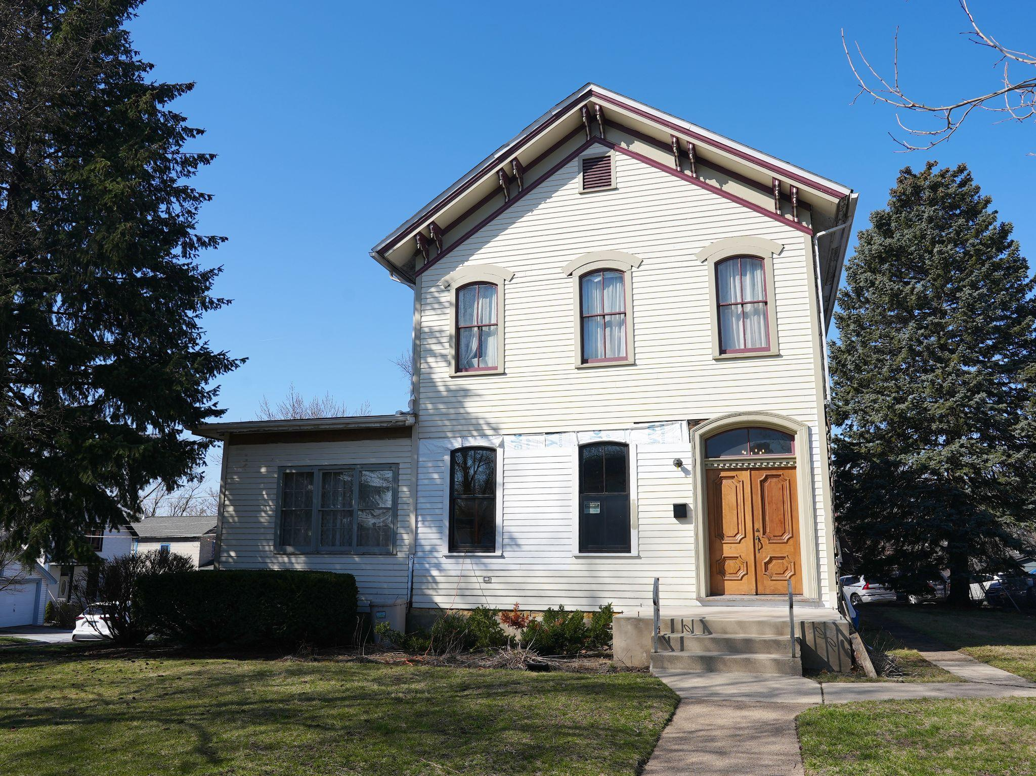
Alt Text: Photo of the front side of a beige two-story house with wood siding.

Tombstone Information:
The Albee House is owned and operated by the Blue Island Historical Society and was built in 1871.
13018 Maple Ave, Blue Island, IL

Object Description:
The Albee House was built in 1871 for the recently widowed Harriet Albee. Harriet’s husband, Cyrus, was born in Vermont in 1813 – one year after the United States lost control of the Chicago River to the Potawatomi in the Battle of Fort Dearborn. Following the defeat, the United States reestablished enduring control of the region that has continued into the present. Although it is not clear when Cyrus moved to Chicago, he bought prime real estate at State and Monroe in Chicago’s early days and set up a butcher shop. Chicago grew with the railroads; by the time of Cyrus’ death, the Rock Island Railroad was built from Chicago through Blue Island to the key grain-producing states of Iowa and Kansas. One can imagine that a mourning Harriet Albee rode on the early Rock Island railroad from Chicago to her new home in Blue Island.
The house has a balloon frame, meaning that wood beams extend from the basement to the roof; this wood was likely sourced from the Blue Island forest which sits on top of a small ridge formed by receding glaciers 14,000 years ago. The house’s foundation is limestone, likely sourced from the many quarries surrounding Blue Island. The limestone was deposited by coral reefs over 400 million years ago during the Silurian period when Blue Island sat under a sea.
While the two-story right side of the house has a deep connection to Blue Island’s natural history, it is not as clear what connection the one-story left side has with the environment. When Harriet Albee died in 1903, the house was passed down to her son, Harry, and his wife, Myrtle. Unfortunately, Harry and Myrtle’s children died during their lifetimes. When Myrtle died in 1942, she gave the home to the Blue Island Women’s Club which used it as a meeting and event space. The Women’s Club received more property around the house, but they sold the extra plots in 1964, likely to fund the one-story addition on the left side of the house. The addition – built sometime between 1964 and 1966 – opened up the interior of the house for larger meetings and events – specifically the regular tea parties hosted by the club. By this time, the Calumet region was highly industrialized and well-connected to the material flows from the entire United States, so it is likely that materials used to build the addition were shipped to Blue Island from elsewhere.
Today, the Albee House is being renovated once again. In the early 2000s, the house was transferred to the Blue Island Historical Society to serve as a meeting place and museum. With support from the local community, the Historical Society started restoring the exterior in 2019 by replacing the aluminum siding with wood, replacing the corbels, and repainting the woodwork. Inside, the wallpaper will come out and the hardwood floors will be replaced. To this day, the house’s structure is still made of trees cut down and limestone carved out of the earth over 150 years ago. Teacups and kettles still occupy the kitchen from the Women’s Club tea parties, and the upstairs is filled with artifacts from Blue Island’s past. History continues to layer itself in the Albee House.

Instagram Description:
The #AlbeeHouse in #BlueIsland is currently home to the @blueislandhistoricalsociety. Built in 1871 for the family of an early #Chicago butcher, the home sat on the #Chicagoland frontier at the stem of the #railroad connecting Chicago to the grain in #Iowa and #Kansas. As Chicago grew, so too did Blue Island. By 1900, the Albee House sat at the junction of the #RockIsland, #GrandTrunk, and #IndianaHarborBelt railroads. The sprawling gardens that once surrounded the house were eaten away by the #urbanization of Chicago in the early 1900s. By 1964, the #BlueIslandWomen’sClub sold off the last of the sprawling property to build an addition on the left side of the house. Since then, the house has served primarily as an event space. Currently under #restoration by the @blueislandhistoricalsociety, the house contains countless artifacts and acts as a repository for Blue Island’s rich and layered past.

Kevin Brown, “The Story of the Albee House – Part 1 of 2,” Blue Island Historical Society,January 29, 2019, https://bihistoricalsociety.org/2019/01/29/the-story-of-the-albee-house-part-1-of-2/.
Ibid.
Kenneth J Schoon, Calumet Beginnings: Ancient Shorelines and Settlements at the South End of Lake Michigan, (Bloomington: Indiana University Press, 2003), 30.
Ibid, 13.
Kevin Brown, “The Story of the Albee House – Part 1 of 2,” Blue Island Historical Society,January 29, 2019, https://bihistoricalsociety.org/2019/01/29/the-story-of-the-albee-house-part-1-of-2/.
Women’s Club 1942 yearbook (in Blue Island Historical Society archives, but not well organized).
Women’s Club 1964 yearbook (in Blue Island Historical Society archives, but not well organized).
Women’s Club 1966 yearbook (in Blue Island Historical Society archives, but not well organized).
“Albee House Restoration,” Blue Island Historical Society, 202, https://bihistoricalsociety.org/albee-house-restoration/

