Undermined Landscapes:
The History and Geography of Iron Mining in Republic, Michigan,
1869–1996

By Owen Castle

Submitted in partial fulfillment of the requirements for the degree of:
BACHELOR OF ARTS
IN ENVIRONMENTAL AND URBAN STUDIES
At THE UNIVERSITY OF CHICAGO

Faculty Advisor: Professor Jessica Landau
Environmental and Urban Studies Preceptor: Anna Selden

April 11, 2025

Abstract
Today, iron is at the foundation of many of society’s technological systems, yet we rarely stop to consider the mines from which iron ore was extracted. Many of these mine sites have halted extraction, rendering their surrounding environments former mining towns. Previous scholarship on mining history has challenged the notion that mines simply close because they run out of ore, instead advancing arguments that centralize the roles of market pressure, government policy, or technological shortcomings. However, this patchwork of explanations is discordant as the aforementioned list has few unifying characteristics. This project attempts to reconcile these fragmented explanations by advancing the framework of “vertical and horizontal geographies of extraction” which embraces the messy and multifaceted processes involved in the development and closure of mines. Horizontal geography studies the connection between mines and markets to primarily understand the role market pressures play in the development and closure of mines. On the other hand, vertical geography analyzes the geologic knowledge and technology central to extraction. The broad categories of horizontal and vertical geographies include the processes behind all explanations for mine closure and allows for analysis of the interaction between different pressures. This project applies the geographies of extraction framework to the Republic Mine — a former iron ore mine in the Upper Peninsula of Michigan (UP). Using archival research, with an emphasis on maps, this paper tracks the development of horizontal and vertical systems at the Republic Mine, from the first plans for mining in 1869 until the mine closed for the final time in 1996. This paper finds that a combination of market pressures, geologic knowledge, and technological advancement guided the Republic Mine’s development. Moreover, market pressures augmented vertical components of mine development to intensify the scale of extraction. In addition, this paper finds that the Republic Mine closed two different times for two different reasons: in 1928, the Republic Mine closed because all the ore that could be profitably extracted had been mined; and in 1981, after new technology enabled the mine to reopen, the Republic Mine indefinitely idled because it could not compete with foreign mines (the mine officially closed in 1996). In both cases, markets viewed Republic as a disposable resource. With mining complete, this project urges readers to consider this narrative to move beyond the extractive logics imposed by markets.

Introduction
Iron is foundational to our modern world: it is in the cars, bridges, ships, airplanes, and railroads that enable movement; iron is in the kitchen appliances and farm equipment that fuel people with food; and it is in the oil rigs, power plants, and transmission lines that power the world’s energy systems. Given the modernity’s reliance on iron, it is odd that we rarely stop to consider that the material is a refined piece of earth, that came from somewhere, which is home to a community of people, who extracted iron ore. The history of mining regions is often tumultuous — company control, labor tensions, environmental destruction, and resource depletion seem to be a cost of extraction. Given modernity’s dependence on iron ore obtained at the cost of these unsavory historical tendencies, the complex history of former mining regions begs further exploration.
The Lake Superior Iron Ore district fueled much of America’s industrial iron ore demand from the late 1800s until the present day. The district comprises four major iron ore ranges: the Mesabi, the Gogebic, the Menominee, and the Marquette. Each of these ranges is home to numerous former mining towns; some have surrendered to the entropic forces of nature while others still support local communities. In many cases, these former mining towns — like many other such towns across the United States — are economically challenged. An historical approach to understand former mining towns in the Lake Superior region enables exploration of the pressures that guided extraction and mine closure. Through an understanding of extraction and mine closure, we can more fully understand how these former mining towns evolved into a state of economic destitution. Moreover, the financial hardship of former iron mining towns around Lake Superior stands in stark contrast to the modern technologies they helped create. Thus, an historical exploration of former mining towns also uncovers why material prosperity differs between mining towns and society at large.
This project focuses exclusively on the Marquette Iron Range in Michigan’s Upper Peninsula (commonly referred to as the UP). The Marquette Iron Range is the oldest of the Lake Superior District Ranges (iron ore was first extracted in 1842), and it still has one active mine., The Marquette Iron Range’s expansive historical timeline allows this project to analyze pressures across the entire duration of extraction in the Lake Superior District. One company — called Cleveland Cliffs — dominates the history of the Marquette Iron Range. Cleveland Cliffs was one of the first companies to stake a claim on the range (with the name “Cleveland Iron Mining Company”), has historically been the largest company on the range, and is the only company that still operates an iron ore mine on the Marquette Range. It is nearly impossible to tell the story of extraction on the Marquette Iron Range without including Cleveland Cliffs as a main character. However, this project does not focus exclusively on Cleveland Cliffs, unlike other histories of the region, and instead focuses on a single mine.
To historically analyze extraction in the Marquette Iron Range, this project focuses on the case study of Republic, Michigan, which is in the Southwest corner of the Marquette Iron Range. The town was home to the Republic Mine, an iron ore mine that was operational from 1871 until 1928 and again from 1956 until 1981. Much of this project centers on the time frame after 1914 — when the mine was bought by Cleveland Cliffs — but analysis concentrates on the mine itself rather than the company. The Republic Mine’s timeline makes it a bellwether for extraction in the Marquette Iron Range: the mine was opened in the post-Civil War mining boom, depleted its ore reserves by the late 1920s, reopened in the 1950s with novel pelletizing technology, and shuttered for good under the unstable market conditions of the 1980s.,
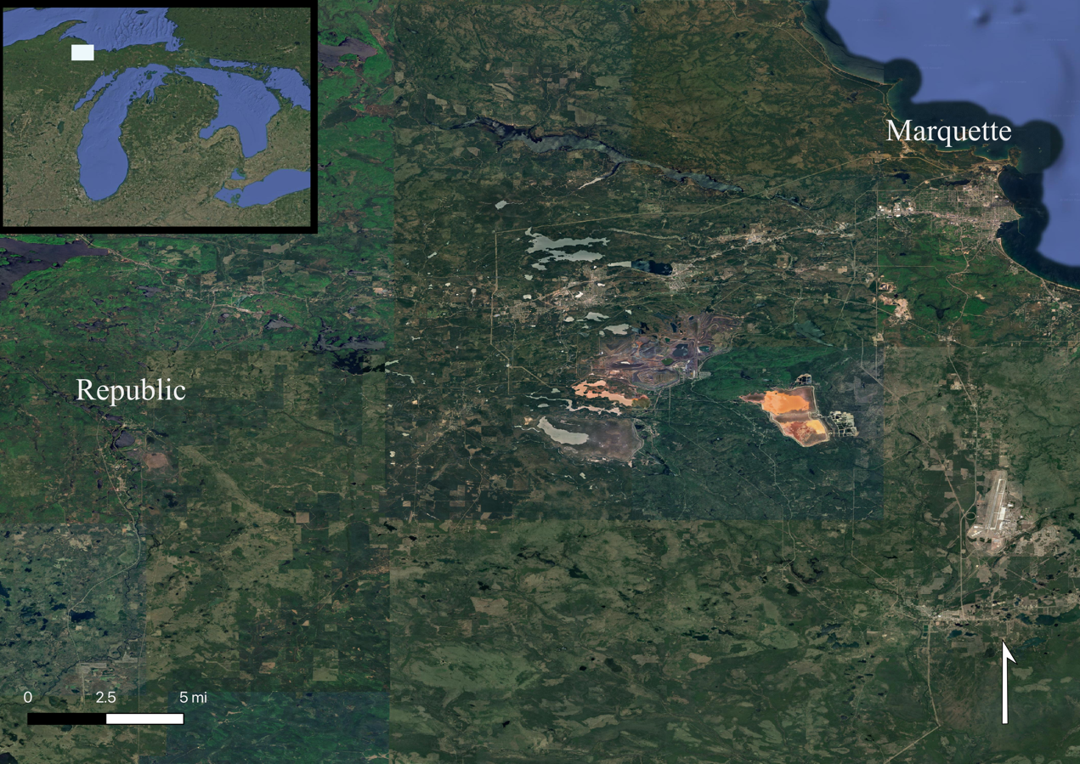
Figure 1. Map of the Marquette Iron Range, created by author using QGIS and Google Earth imagery.
Geographically, Republic is extremely remote. A six-hour drive from Chicago, seven hours from Detroit, and nearly five hours from Duluth, the town is truly in the middle of nowhere. Nevertheless, iron ore from this billion-year-old deposit was shipped by some of the largest companies of the late 19th and early to mid-20th centuries to Chicago, Detroit, and Cleveland where these industrial powerhouses transformed the rock into iron and steel that was cast, rolled, and fused together into bridges, boats, tractors, cars, planes, and skyscrapers. Republic may be geographically remote, but a system of commerce and production brought the Republic Mine’s ore into every corner of the United States.
The commercial flow of Republic’s ore was enabled by geographies of extraction — the abstract idea that humans could rework the landscape in service of producing and transporting iron ore. The term “geography” is used in this phrase because records indicate that people planned out reworked landscapes on maps before they were implemented. Geographies of extraction took place on two different planes. The first plane was the horizontal surface of the earth. Plans were made, and subsequently implemented, to connect the Republic Mine to distant markets over railroads and Great Lakes shipping lanes. Additionally, the workers who operated the mine were geographically dispersed, so infrastructures — such as automobile roads — were constructed to connect homes with mines. The horizontal geography of extraction is comprised of all the infrastructure laid across the earth’s surface to facilitate extraction. Because these technological systems served as the mediator between the mine and markets — whether it be commodity or labor markets — the category “horizontal geography” enables an analysis of the relationship between the Republic Mine and markets.
The second plane, orthogonal to the first, was the vertical ore deposits and mine networks underneath the earth’s surface. The composition of vertical ore deposits was mapped out by early surveyors in Republic. Later, geologists and miners tunneled through the earth, using various industrial technologies, in search of ore bodies. The vertical geography of extraction is comprised of the geologic knowledge and technical mining systems in the Republic Mine that facilitated ore exploration and extraction. The category “vertical geography” enables an analysis of the various technologies used to support mining and the various mining methods performed. Before Republic’s geography was reimagined, the land was geographically remote and valueless — any notion that the land could be valuable for its iron ore reserves was only an idea. However, once vertical mine shafts and horizontal railroads connected ore bodies to markets, the idea of value became a reality.
Under this framework, the idea of “control” is central to this thesis’ analysis. Control with respect to the geographies of extraction is the ability to plan and successfully implement a new geography. With this understanding, control is demonstrated by a set of actions that work to reshape the landscape. This thesis will show that the basis of Cleveland Cliffs’ vertical control was the company’s ability to map out the location of ore bodies in Republic, then implement a mining system to remove those ore bodies. Additionally, the basis of Cleveland Cliffs’ horizontal control was the company’s ability to ship ore over railroads and freighters — whether they were owned by the company or not — to distant ore markets. These two forms of control interacted with each other because Cleveland Cliffs could only exert vertical control if it had horizontal control; iron ore would have no value, and therefore the company would not be incentivized to operate the mine, without an ability to horizontally ship extracted ore to markets for a profit. Additionally, the company could only exert horizontal control if it had vertical control; there would be no point in constructing a horizontal geography that connected the mine to markets without valuable iron ore bodies that garnered market interest. In this sense, the horizontal and vertical geographies were intimately tied together. In fact, this project will show the two geographies augmented each other; as one geography intensified, it induced intensification in the other geography, resulting in a positive feedback loop.
The extractive logics brought to Republic enabled power to be centralized remotely; the decision makers that affected the Republic Mine could be in geographically distant places and still control the mine to reap its profits. This point is highlighted by the fact that Cleveland Cliffs — a corporation based in Cleveland, Ohio — owned and operated the mine from 1914 onward. In fact, Cleveland Cliffs was the most commercially powerful company on the Marquette Iron Range; in the early 1900s, the company owned the most mines on the range, it owned a railroad to connect mines to a port on Lake Superior, and it owned a fleet of iron ore freighters to bring ore to markets on the Great Lakes. This remote, central authority over Republic was made possible by the railroads and shipping routes that collapsed the distance between the mine, markets, and company headquarters in Cleveland. Moreover, this extractive system viewed land as a resource: distant investors, such as Cleveland Cliffs, understood Republic in terms of the profit they obtained from the land. Remote power, bolstered by geographies of extraction, fostered a system in which Republic was viewed as a resource to be exploited by Cleveland Cliffs.
This thesis argues that the closure of the Republic Mine was not inevitable — it was the direct consequence of human decisions. Mine closure can be explained in terms of horizontal and vertical geography. As the two geographies augmented each other, the intensified vertical geography depleted accessible ore reserves. Once the easily accessible ore reserves were extracted, the markets that were horizontally connected to Republic stopped demanding ore from the Republic Mine, turning to more competitive mines instead. While this argument generally explains both mine closures — the one in 1928 and the one in 1981 — it does not explain why the mine reopened in the 1950s and it leaves out important details of the 1981 mine closure. In the 1950s, the implementation of new technology capable of refining low grade ore into a marketable product brought markets to once again value ore from the Republic Mine. This new technology, however, could not indefinitely placate markets which were susceptible to external pressures. The mine closure in the 1980s was one casualty of a much larger market crisis that hit American iron and steel industries in the wake of globalization. Vertical geography played a role in the 1980s mine closure, but a much smaller role than the previous closure. Overall, this project finds that the interaction between horizontal and vertical geographies brought about mine expansions and mine closures.
Viewed as a resource, once all the value was squeezed out of the Republic Mine, investors left the town behind and looked to make money elsewhere. This paradigm was destructive to Republic’s landscape, leaving a craterous hole in the earth at the site of the open pit mine. It was also destructive to the town’s population which is currently decreasing and aging. Today, as we reside in steel buildings, drive steel cars, and ship commodities over steel ships and railroads, we owe a debt to the overlooked iron mining towns that enabled these modern infrastructures. However, this debt cannot just be a repayment of financial costs. Instead, redress necessitates people to work toward a future decoupled from the extractive logics that exhausted valuable commodities in Republic, then left the town behind.
To analyze the vertical and horizontal elements of mine closure, this thesis applies archival methods to company records, state reports, and newspaper archives. However, analysis of these sources mostly provides deeper meaning and context to the six horizontal and vertical maps of Republic presented in the sections that follow. These maps are central to the argument because they demonstrate the spatial features of extraction; with additional context, these maps reveal spatial contradictions engrained within Republic’s system of mining. In certain cases, however, maps do not sufficiently explain important developments in the Republic Mine’s history. In these cases, spatial description of the Republic Mine will ground the argument in the geographies of extraction framework.
The body of this thesis is split into four sections, each corresponding to a “rise” or “fall” of a mining technique in Republic. As a coherent whole, these sections describe the two cycles of extraction Republic underwent from inception through completion. In the first section, this thesis briefly describes white settlement in the Marquette Iron Range and the new logics mining companies brought to the landscape that enabled geographies of extraction to take hold. After establishing this preliminary, the main thrust of this section analyzes how horizontal and vertical geographies worked in Republic to develop the shaft mine, focusing on how the interaction between market pressures, geologic knowledge, and technology intensified extraction. However, this intensification led to a crisis of iron ore depletion, which is explored in the following section. This crisis culminated in Republic’s first mine closure, which was caused by a combination of market pressures and geologic realities. In the wake of the first mine closure, Republic’s horizontal geography morphed to support car travel which facilitated the flow of miners between their homes in Republic and work at mines outside of Republic.
After the shaft mine failed, a new system of pit mining and low-grade ore beneficiation proliferated in Republic during the 1950s. The third section focuses its analysis on how the methods and technology of mining in the 1950s were far more intense than mining practices before the 1920s, leading to more extreme landscape change and environmental destruction. However, the Republic Mine faced a new crisis in the 1980s, independent of mining practices at the mine itself: foreign trade. Global economic pressures caused the Republic Mine to indefinitely idle in 1981 and officially close in 1996. Since the mine has not reopened in subsequent years, this narrative tells the entire story of extraction in Republic up to the present day. With this historical narrative in mind, I urge readers to imagine a future for Republic freed from the successive periods of boom and bust and freed from logics of extraction that view Republic as a mere resource. Hopefully, this narrative can help bring about a brighter future to Republic and other former mining towns.

Literature Review
Understanding horizontal and vertical geographies of extraction requires a review of literature on the systems that fit the criteria of each plane. While numerous scholars have explored the histories of horizontal and vertical geographies, few have explored how these geographies are linked and none have focused their analysis to the Marquette Iron Range. Understanding how the vertical and horizontal components of mining are connected provides a more nuanced understanding of mining history and the market logics that have frequently guided mine development. Additionally, while previous scholarship focuses on the economic, technical, and geologic determinants of mine closure, this project will contribute to such scholarship by analyzing mine closure under the framework of vertical and horizontal geographies. This analysis will better explain how the interdependence of market pressures and physical depletion — both the direct consequence of human decisions — resulted in the Republic Mine’s closure.

Horizontal Geographies
Scholars have previously studied the ways in which technology reimagines landscapes to connect places. Canals, railroads, and automobile roads all result from the deployment of technology to rework the earth’s surface in order to facilitate the movement of people and goods. While scholars did not use the term “horizontal geography” to describe these infrastructures, it is reasonable to categorize them together under this label because they all lie on the earth’s surface and foster the flow of goods and people between places. Specifically, they all work to facilitate the flow of extracted resources to markets. Scholars find that in addition to connecting places, these horizontal geographies are tools to bring market logics to geographically dispersed places, resulting in intensified extraction.
Key to understanding both horizontal and vertical geographies of extraction is an understanding of the energy and material regimes that guided development. Lewis Mumford split these regimes into three phases: the “eotechnic phase” guided by water as the main source of energy and wood as the dominant building material; the “paleotechnic phase” guided by coal as the leading source of energy and iron as the standard building material; and the “neotechnic phase” which relied on electricity for power and metal alloys for building materials. In this thesis, I will mostly constrain my study to the eotechnic and paleotechnic phases. During the eotechnic phase, human beings ceased being the “prime movers” of goods. Instead, a new geography of canals was constructed that facilitated the flow of goods and “effected a closer union between town and country.” This new geography continued through the paleotechnic phase but was dominated by new technology that intensified geographic connections. In this phase, steam powered railroads collapsed the distance between places and “tended toward monopoly and concentration” in the location of railroad termini. This concentration of power caused railroad logics to proliferate, spreading “the quantification of life” where success was only measured in terms of quantity of production. The eotechnic and the paleotechnic infrastructures resulted in a new horizontal geography that collapsed the distance between places connected by canals or railroads and concentrated power in markets.
The paleotechnic’s horizontal geography was dominated by railroads that worked to maximize production. George Vrtis has shown how railroads linked coal mines in Colorado to markets along the East Coast. While this connection led to a period of economic prosperity in the mining districts, it also resulted in an intense period of extraction that caused extreme environmental change. The intense extraction motivated by railroads was not constrained to the mining industry. William Cronon has demonstrated how railroads connected Midwest resource regions with markets in Chicago. While he did not study the role of railroads in the mining industry specifically, he did claim broadly, “The railroad… became the chief device for introducing a new capitalist logic to the geography of the Great West.” By linking markets to resource reserves via the new horizontal geography of railroads, market logics guided extraction. After the capitalist logic was applied to resource regions, “The postrailroad landscape would require much higher levels of trade, production, and resource consumption for its own subsistence…. More and more of western nature would become priced, capitalized, and mortgaged as the new capitalist geography proliferated.” Applied to mining, the capitalist logic brought from markets to mines via railroads would cause intensified extraction. Because extraction occurs on the vertical geography of mines, Cronon seems to suggest that the horizontal and vertical geographies are related. While Vrtis studied this relationship to show how railroads supported the movement of ore, he did not mention the “capitalist logic” inherent to railroad development that Cronon observed. By studying how railroad companies brought intense extractive logics to Republic, this thesis shows how railroads directly shaped mine development in more complex ways than just promoting the flow of extracted ore.
Lewis Mumford’s energy regimes say little about cars and roads, likely because he was writing in the 1930s at the dawn of the automobile era. Nevertheless, cars, and the roads they required, were a key feature in Republic’s horizontal geography. Christopher Wells has studied the geography of roads in detail. The main difference Wells observed between railroad geographies and automobile road geographies is that railroads were linear while roads were nonlinear; the horizontal geography of roads comprised a latticework of connections, instead of a straight railroad line. The new geography of roads collapsed the distance between rural places because drivers were able to make longer car trips. As a result, rural economic centers spatially consolidated as people could travel greater distances to their place of employment and shopping locations. Rural places, like Republic, experienced a new horizontal geography as a result of the car that allowed people to live more dispersed from economic centers. This research uses this framework to understand how the horizontal geography brought about by cars connected geographically dispersed miners to mine locations.
Another element of horizontal geography that Mumford overlooked was the globalized horizontal geography after World War II. Globalization enabled American investors to develop foreign ore reserves and ship extracted resources to America. While this global horizontal geography did not directly serve Republic, the mine was forced to compete in markets connected horizontally to both Republic and foreign ore. This research will explore how Republic’s regional horizontal geography interacted with the global horizontal geography.
Canals, railroads, automobile roads, and shipping lanes supported the development of the Republic Mine. These horizontal geographies both connected the Republic Mine to markets and brought new logics to mine development. This thesis will build on previous research by analyzing how different infrastructures, and the logics associated with each, relates to mining. Specifically, this thesis will focus on how horizontal geographies relate to mine closure, demonstrating how market logics were partially responsible for undermining the Republic Mine. Additionally, this research will add to the current literature by applying such an analysis to the Marquette Iron Range by using Republic as a case study.

Vertical Geographies
The previous section mentioned how the horizontal geography brought by railroads intensified extraction. However, intensification of vertical geographies was not described. Scholars of mining may not use the term “vertical geography,” but the mining systems they describe all assume a vertical geography; technology was required to extract resources and construct a system of man-made tunnels and caverns through the earth. This abstract label allows analysis of different mining methods by comparing different vertical geographies. Additionally, the label enables this research to draw out the relationship between vertical systems and horizontal geographies. Scholars use different frameworks to understand how mines operate; some frameworks are reliant on geological realities, others on market demands, and still others focus on technological advancement. Each of these frameworks provide insights into how mines operate, mature, and eventually close. Additionally, scholars find that the verticality of mining shapes horizontal trade networks by providing the material foundations for transportation systems.
Lewis Mumford argues that the development of the mining industry is the key event that marks the transition from the eotechnic to the paleotechnic periods. While understanding the eotechnic is important to grasping how horizontal geographies function, mine development in Republic relied entirely on paleotechnic logics. One of the main points Mumford makes about mining is that “paleotechnic industry rested on the mine.” This is because the key technology of the era — railroads — relied on mined iron to construct rails and locomotives. This shows a two-way relationship between the vertical and horizontal geographies; in addition to horizontal geographies connecting mines to markets, vertical geographies supplied railroads with their fundamental material: iron. This research will explore this two-way relationship in further detail.
However, Mumford also pinpoints a central contradiction in the mining industry. Mumford points out that mine owners are “constantly consuming [their] own capital, and as the surface measures are depleted the cost per unit of extracting minerals and ores becomes greater.” This seems to suggest that mine closure is inevitable as mines increase in depth, but other scholars disagree. Lisa Wilson focuses her analysis on the “resource roller coaster” that mining communities experience as prices rise up and down at the behest of markets. This lens shows how the horizontal geography of extraction affects the vertical geography: market demands shape the intensity of extraction. Mining companies consuming their capital is as much of an issue as the market pricing of ore under this framework. However, Daviken Studnicki-Gizbert does not view vertical geographies so linearly. Instead, he sees that mining “passed through a series of cycles, each defined by the expansion, maturity, and decline of a particular mining regime.” While mine owners may have exhausted their vertical geography under a particular mining regime, new technology will eventually allow mining to continue. This research will explore the effects of depleting resources, market pressures, and technological advancement on the development of the vertical geography in Republic.
Republic’s vertical geography was reworked on numerous occasions; the mine first operated as a shaft mine which was kept open through technological advancements, and the mine’s verticality was reworked as an open pit mine after ore reserves in the shaft mine were exhausted. By analyzing vertical geography, this research explores the technologies that supported mining, and how those technologies related to horizontal trade flows. In addition to technology, this thesis analyzes market and geologic pressures on mine development. This research will build on current research to show how existing frameworks of mine development relate to each other by showing how geology, markets, and technology together guided mine development. Additionally, this research will add to the literature by applying these frameworks of mine development to the Marquette Iron Range.

Explanations of Mine Closure
The fates of mines are closely tied to the resources they produce. This strong connection between ore markets and mining towns can be explained by the “resource roller coaster” framework; mining towns’ dependence on a single resource that has varying prices and availabilities over time mimics the ups and downs of a roller coaster. Additionally, different towns have different social, political, and economic characteristics which cause different communities to experience those ups and downs differently. The resource roller coaster suggests that mines may close for different reasons, but all of those reasons are tied to the resource itself.
However, some authors suggest that mine closure has little to do with the resource itself and more to do with the rate of technological advancement. Many authors describe the history of Lake Superior Iron Ore District mining as a history of technological advancement. On the Mesabi Range, successful iron mining companies mechanized their mines. The same is said on the Marquette Iron Range. On both ranges, even when it seemed that resources were depleted, a technological advancement that could turn low-grade iron ore into high-grade ore revived the local mining economies. Similarly, in copper mines on the Keweenaw Peninsula, stamp mills were invented to enable companies to extract bands of copper, which would have been impossible without the technology. Technology allowed mines to continue operations, even with alleged resource depletion.
Looking beyond the Lake Superior region, Daviken Studnicki-Gizbert’s cyclical theory of mine development postulates that particular mining regimes extract a mine’s reserves to exhaustion, but subsequent regimes enable further extraction. In Mexico’s Sierra Madre gold district, Studnicki-Gizbert found that “capitalist mining push[ed] past the limits of exhaustion thanks to new and more powerful assemblages of laws, technology, and energy flows.” Thus, mines meet technological or legal limits that force closure, but technological advancements or a change in legalities enable extraction to continue. In the Sierra Madre, this meant mine development and closure “repeated itself, and then repeated again.” This non-linearity of mine development shows the role a given set of technologies plays in determining mine closure. This project builds on this research by analyzing technological regimes to explain mine closure.
Nevertheless, many of the mines that underwent technological advancement have closed for reasons closely tied to resource markets. Cleveland Cliffs cites the “steel crisis” for the closure of many of their mines, including the Republic. When many steel companies filed for bankruptcy in the 1980s, the partnership between Cleveland Cliffs and steel companies to finance their low-grade ore operations failed and forced the company to restructure, closing many of their mines. On the Mesabi Range, the same steel crisis pressures were cited for mine closures in the 1980s, plus competition from low-cost, foreign ore. Many iron mines seem to close due to market conditions; the high cost of operating technologically advanced mines resulted in uncompetitively high ore prices. This explanation seems to extend to other industries too, including coal mining in Colorado. This argument seems to undermine the notion that mines close because they cannot keep up with technological advancements.
Despite these competing explanations, each one seems to partially explain mine closure. While fears of resource depletion may lead to technological advancements that keep mines operational, those high-tech mines continue to deplete finite resources. The scarcity of resources and costlier mining technology leads to exceedingly high costs of extraction that prevent mines from operating efficiently, causing market demand to collapse. For example, every copper mine along Lake Superior closed because, “They did not run out of copper; they ran out of copper they could mine profitably.” Altogether, geologic limits, economic incentives, and technological advancement seem to be at play in explanations of mine closure, with each explanation being partially culpable.
This thesis’ “geographies of extraction” framework engages geological, economic, and technological explanations together to explain mine closure; horizontal geographies enable an analysis of market pressures, and vertical geographies allow for analysis of geological and technological pressures together. Moreover, by studying the relationship between vertical and horizontal geographies, this research will put all these explanations of mine closure into conversation with each other. In so doing, this thesis will both assess the validity of each explanation and show how geologic, economic, and technological analyses cumulatively explain mine closure. Additionally, this research adds to the existing literature by exploring horizontal and vertical geographies in the Marquette Iron Range, using Republic as a case study. Thus, the results here are specific to Republic — other mines are subject to unique pressures that may cause mine closure for different reasons. Nevertheless, the analytic of horizontal and vertical geographies can still be applied to other mines to explore the unique conditions around mine closure.

Building a New Geography (1869–1925)
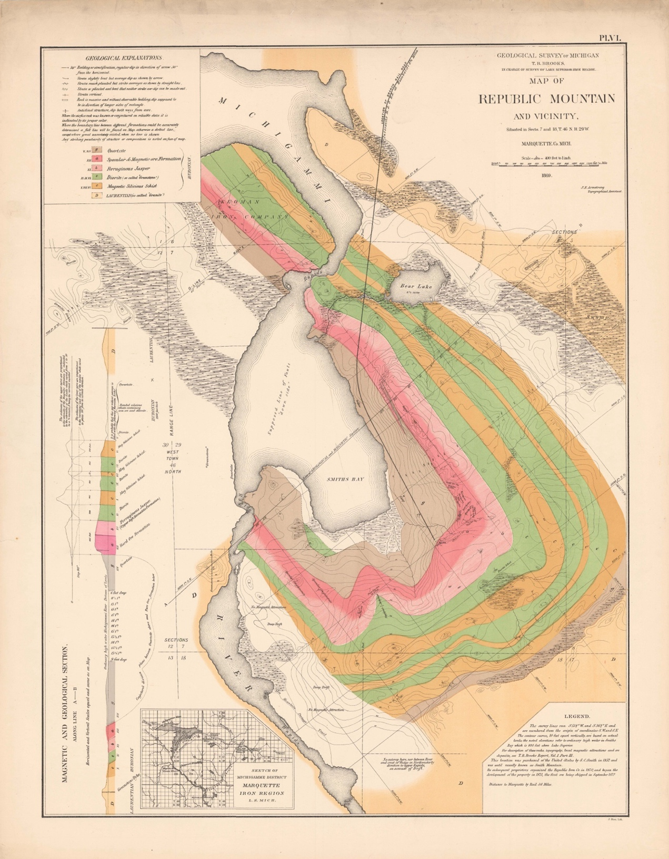
Figure 2. Geological Map of Republic, 1869.
The first map of Republic (Figure 2) combines vertical and horizontal features on a single two-dimensional surface. This choice was not arbitrary. The verticality of Republic is documented through the Earth’s mineral composition — the map shows were beneath the surface lies quartzite, diorite, schist, granite, jasper, and the prized specular hematite. Dig in the wrong place and find unvaluable rock. However, with the verticality of Republic mapped, speculators could determine where to dig and uncover the vast wealth of specular hematite (an iron ore). However, the map is not just a guide that tells mining companies what is beneath their feet; it also documents rivers and lakes, wetlands and marshes, hills and valleys, and horse roads and railroads — Republic’s horizontality. This horizontal layer guided development: where the town would be platted, where wetlands would be filled, and where railroads would be laid. It is no coincident that the inset on the lower left of the map shows where a proposed railroad branch would be built; without a railroad, the rich minerals contained in Republic’s verticality would not be connected to any markets that would assign them value. Thus, key to understanding Republic’s period of extraction is an understanding of how the town’s vertical and horizontal geography were constructed, and how they interacted with each other.
While this map offers many clues into how the geographies would interact — for example, the map suggests that transportation networks would be constructed to link Republic’s mineshafts with markets — it also leaves out important particularities. The map does not describe a vertical cross-section of the ore bodies; instead, the map only shows a projection of vertical ore bodies onto the horizontal plane. Additionally, the market valuation of the ore in the bodies depicted on the map is not included, making it unclear whether markets will be interested in purchasing Republic’s ore. Similarly, mining and transportation costs are not included on the map, making it unclear whether extraction would be profitable. Finally, the map is static and does not show the dynamic physical processes that would take place in Republic, including physical labor and the depletion of ore bodies. Much of this data would have been impossible to predict in 1869, but these pressures would be central to the Republic Mine’s development. While this map introduces horizontal and vertical geographies in Republic, the geographical elements that are not included on this two-dimensional surface will be this section’s main point of analysis. This will allow a better understanding of why the Republic Mine closed for the first time just 56 years after it opened.

The Pre-extractive Period
The Marquette Iron Range, and Republic specifically, underwent transformative changes throughout the 19th century as new mining and logging operations began. These changes were made possible by a new geography of extraction. However, the new geography required three preconditions before extraction began: (1) the conceptualization of a new horizontal geography; (2) American sovereignty over the Marquette Iron Range; and (3) the discovery of iron ore, a valuable commodity. These preconditions were met between 1787 and 1843, laying the foundation for the industrial transformation of the Marquette Range’s geography.
The Northwest Ordinance reconceptualized the Great Lakes Region’s horizontal geography. Written in 1787, the ordinance described how American territorial gains from the British — including modern-day Ohio, Indiana, Illinois, Michigan, Wisconsin, and parts of Minnesota — would be administered by the United States. Article IV of the ordinance explicitly described a new system of commerce: “The navigable waters leading into the… St. Lawrence… shall be common highways, and forever free… without tax, impost, or duty therefor.” As a part of the St. Lawrence River system, the Great Lakes were understood to be a medium of commerce. This understanding of the Great Lakes fits within Mumford’s “eotechnic phase” because maritime transportation relies on water to more efficiently move goods. Increased efficiency would collapse the time and energy needed to move goods such as iron ore between Great Lakes ports. Once implemented, the new horizontal geography would foster commerce throughout the Great Lakes.
American sovereignty was required to build new horizontal geographies, and the discovery of valuable commodities were necessary for commerce. On the Marquette Iron Range, the discovery of iron ore came first, in 1842, but geologists had to contend with the Anishinaabe Indians already living in the region. The Anishinaabe were removed after the Treaty of LaPointe was signed — also in 1842 — which ceded the Western UP to the United States, allowing mining companies to buy land on the Iron Range. With this, extraction could commence, and trade networks could be laid to connect mines with markets. This would allow for the commercial flow of Marquette Iron Range ore throughout the region in the second half of the 1800s.

Building a New Horizontal Geography
Before extraction began in Republic, other Marquette Range mines developed railroads and shipping routes to connect ore reserves with markets. Because rugged terrain separated the iron ore deposits from Lake Superior, mining companies built a railroad between prospective mines and the lake-port of Marquette in 1857. At the same time, the US Army Corps of Engineers built the Soo Locks on the Saint Mary’s River between Lakes Superior and Huron, eliminating a portage. These two infrastructure projects efficiently linked ore mines to prospective markets on the Lower Great Lakes; ore could travel exclusively by rail from mines to the port in Marquette, then onwards entirely by boat to any port on Lakes Huron, Michigan, or Erie.
However, iron ore extraction required markets, but few existed in the 1840s and 1850s which prevented early mining operations to expand to Republic. The Civil War quickly changed this as the United States relied on ironclad armaments to sustain the war effort, causing demand for Marquette Range ore to increase. Following the war, “The armament industries, whose plants were over-swollen… sought new markets,” in railroads and manufacturing industries, sustaining high demand for iron ore. This increased demand is reflected by the fact that before the war in 1860 there were three active mines on the Marquette Iron Range, and after the war, in 1867, there were 14 mines — a 367% increase. The post-Civil War mining boom brought the Republic Iron Mining company to invest in the region, opening the Republic Mine in 1871. With the new horizontal geography laid, and markets for the region’s ore found, Republic’s extractive period began in the 1870s.
To support extraction, a railroad branch was built to Republic in 1872, allowing ore to be shipped from the Republic Mine to the port in Marquette. This branch line was an actualization of the Marquette, Houghton & Ontonagon Railroad’s proposed line shown in Figure 2. Like other railroad branches across the United States, the line to Republic increased market access to resource reserves. Thus, the efficient combination of trains and boats that supported other mines on the range extended to Republic, facilitating the flow of ore to markets on the Lower Great Lakes.
Railroads and Great Lakes shipping induced a new vertical geography of deep shaft mines in Republic, guided by capitalist logics brought by the railroads. These capitalist logics demanded that iron ore be extracted from the Republic Mine and shipped to markets for the first time in 1872. However, the capitalist logics not only demanded extraction, but demanded a high rate of extraction due to the railroads’ requirement for increased levels of trade. In 1914, when data on the Republic Mine first became available, the mine extracted a total of 47,457 tons of ore — an industrial level of production fit to satisfy mining and railroad companies. Production at this level over the previous 42 years resulted in Republic becoming vertically hollowed out. In 1914, the deepest mineshaft extended 2,050 feet deep and grew even deeper as mining persisted. Markets demanded high levels of extraction which vertically reconstituted the town through intensified mining operations.
The relationship between the horizontal and vertical geographies in Republic was not just one-way because iron ore mining also intensified railroad and shipping networks. Cronon argued that railroad investors during the late 1800s and early 1900s believed, “A railroad was a pool of capital designed to make more capital.” Because iron ore was converted into the cast iron and steel needed to make rails and locomotives, railroads converted their initial capital investment into more capital when they hauled iron ore from the Republic Mine. Similarly, iron mining also intensified the Great Lakes shipping industry, which utilized “freighters” with iron hulls to transport ore throughout the region. The 1880s Great Lakes folk song Red Iron Ore about a ship hauling ore between Chicago and Escanaba (a Great Lakes port town on Lake Michigan that exported ore from the Marquette Iron Range) describes how iron mining intensified shipping:
Come all ye bold sailors who follow the lakes,
On an iron ore vessel you’re livin’ to make,
I shipped in Chicago, bid adieu to the shore,
Bound away to Escanaba for red iron ore.
The boat described in this song is an “iron ore vessel” in two senses: the ship hauls iron ore and is made of iron. Workers were living to make the ship in a very literal sense because they worked to convert the initial capital investment in the ship into more capital through commerce. As ore was extracted from Republic, it was used to build more freighters and railroads that intensified trade flows.
The two-way relationship between horizontal and vertical geographies of extraction resulted in a positive feedback loop in which the two geographies augmented each other. This system of augmentation was witnessed by the Chicago, Milwaukee & St Paul (CM&SP) Railway which extended service to Republic from Chicago in 1891. When justifying the purchase of the Republic line, the CM&SP railway told its shareholders, “These lines of railway are a valuable acquisition to your company—especially because they give access to the iron regions of the Peninsula of Michigan.” After almost 20 years of operation, Republic’s intensified vertical geography attracted the CM&SP railway to invest in the new line. To support their new line, the railway bought a total of 225 ore cars between 1891 and 1892 enabling more ore to be transported to markets., This caused an increase from 243,215 tons of iron ore shipped over the railway in 1890 to 330,066 tons in 1893., The increased number of shipments meant that the Republic Mine extended deeper, and the number of shipments grew because previous extraction attracted the railroad line to extend service to Republic. This positive feedback loop drove the Republic Mine deeper into the Earth.
By 1912, the Republic Mine was the fifth largest mine on the Marquette Iron Range, out of 34 total. The augmented vertical and horizontal geographies fostered the mine’s prosperity by channeling market demand into the Republic Mine’s development. This analysis shows the centrality of markets in the mine’s success which reveals how Republic was viewed as a resource: extraction was motivated by markets guided by the profit incentive. However, to extract value from Republic, mining companies were guided by mining technologies and geologic knowledge.

Developing a New Vertical Geography
Technology and geology shaped a unique vertical geography in the Republic Mine. Other scholars have studied how technology shaped mine development; Vrtis stated that coal miners in Colorado during the late-1800s “were able to free themselves of earlier transportation and energy regimes… and send mining… hurtling forward at [a]… furious pace.” A similar process occurred in Republic: the new carboniferous energy regime of the 1800s enabled technologies that supported intense mining practices. In addition to technology, geologic knowledge dictated where mining technology would be deployed. The interaction between mining technology and geologic knowledge guided the Republic Mine’s development, pushed by the market pressures previously described. As the mine grew deeper, technological advancement allowed extraction to continue. Moreover, many technological advancements enabled extraction to continue with increased efficiency. The analysis in this section will rely on Cleveland Cliffs’ company records. Although the company bought the mine in 1914 — and so their practices only account for the final six years of analysis in this section — earlier companies that operated the Republic Mine do not have readily accessible records. The practices described in Cleveland Cliffs’ records is a case study that can be extrapolated to explain mine development over the entire extractive period.
Under Cleveland Cliffs, the Republic Mine employed two mining techniques: shrinkage stope systems and drifting. In a shrinkage stope system, miners would dig underneath an ore body to detonate it from below, then miners would remove the dislodged ore that fell from the explosion. Drifting, on the other hand, required miners to dig horizontal tunnels and remove dislodged ore in the process. These techniques guided the shape of the Republic Mine’s vertical geography, physically characterized by tunneled drifts and cavernous stopes. However, technique alone did not shape the mine’s development because geologists determined the locations of ore bodies. This knowledge guided where mining techniques would be deployed.
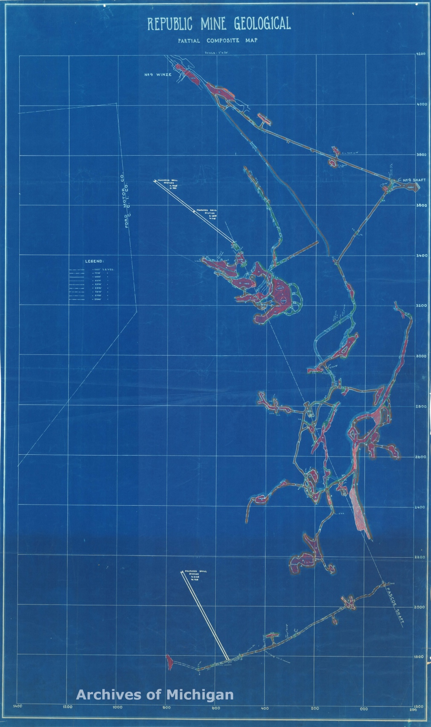
Figure 3. Map of the Pascoe Shaft, Republic Mine, 1928.
Figures 3 and 4 show how technique and geology converged to produce a new vertical geography. While both maps were produced in 1928 (which is later than this section’s period of analysis) many of the ore bodies depicted in the maps were mined before 1925. Figure 3 shows both hollowed-out stopes — which are the irregular shapes — and tunneled drifts — which are depicted by the parallel lines running between stopes. The colors shaded within these shapes show which rocks were mined at a given location: red corresponds to locations where iron ore was extracted, and brown and green correspond to jasper and granite, respectively. The map explicitly shows the Republic Mine’s reworked vertical geography by depicting the spatial layout of the mine’s physical features. The mine’s vertical geography was reworked into the form depicted in Figure 3 after geologists mapped the location of ore bodies using drills that took rock samples hundreds of feet deep. After these explorations, geologists found that valuable ore bodies were “irregular” in shape, resembling a “convex lens” that at its base was “two or three feet wide,” but “[ran] from that width to fifty feet in places and [were] several hundred feet thick.” Miners would only extract iron ore from the locations where geologists found these oddly shaped ore bodies. The fact that the stopes and drifts depicted in Figure 3 are primarily red confirms that geologic knowledge of the location of ore bodies guided the mine’s development. Moreover, the shape of ore deposits at the Republic Mine lent themselves to a shrinkage stope system because miners could most efficiently remove the entire thick ore body by continually blasting from below, demonstrating how geologic knowledge guided which mining techniques were used. This reveals that the Republic Mine was developed under a system in which geologic knowledge guided where technology would be employed to mine valuable iron ore reserves.
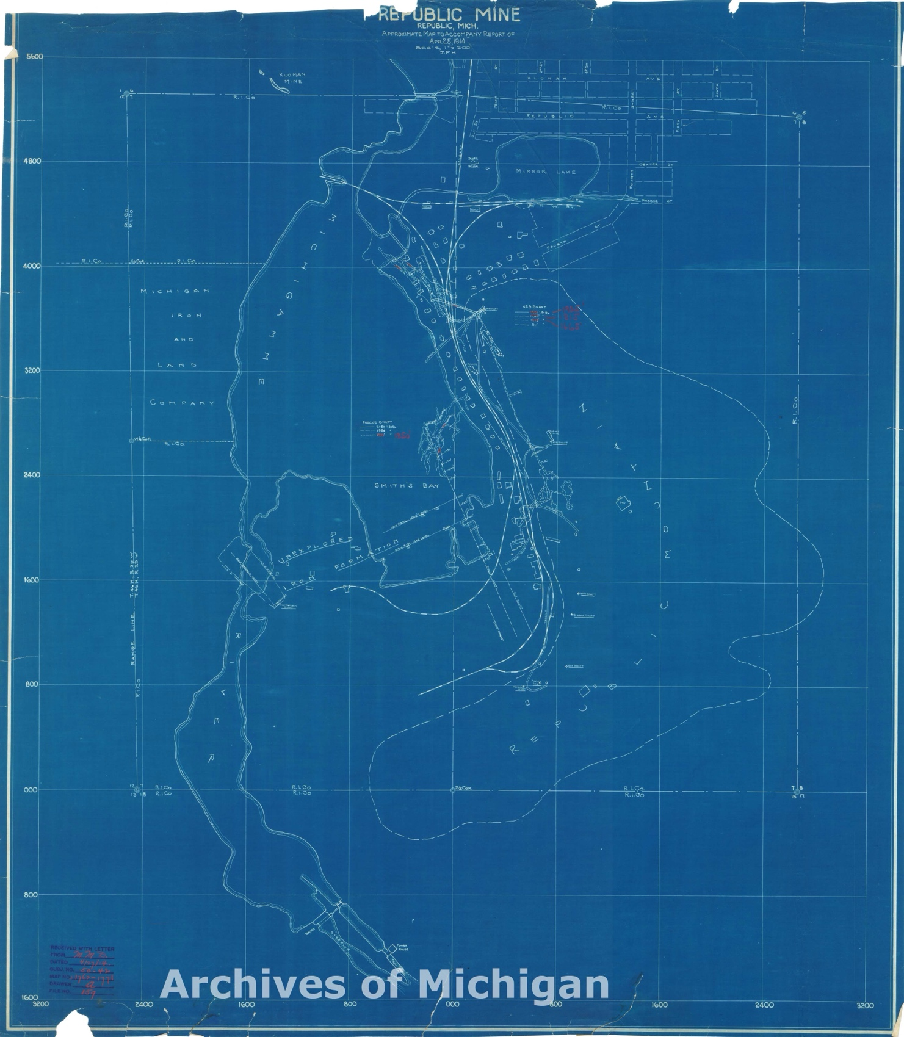
Figure 4. Map of Pascoe Shaft and Republic, Republic Mine, 1928.
However, the mine’s vertical geography was not exclusively composed of static stopes and drifts. Figure 3 shows that all the stopes and drifts were connected to a dashed line depicting the Pascoe Shaft. This shaft extended from the surface to the underground locations of ore bodies. In figure 4, the Pascoe Shaft intersects the surface where the thin dashed line in the center of the map ends, close to the thick dashed lines depicting railroads. This shows how the mine shaft connected underground, dislodged ore to railroads that transported ore onwards to markets. Within the mine shaft, machines moved ore from the location of deposits to the surface. Because it was the deepest shaft at the Republic Mine, the following analysis of the dynamic machines that composed the mine’s vertical geography will focus exclusively on the Pascoe Shaft. Technological advancements enabled the Pascoe Shaft to extend deeper and mine increasingly difficult to access ore bodies more efficiently, allowing Cleveland Cliffs to continually push past technical limits.
Cleveland Cliffs used two machines to move ore through the Republic Mine’s Pascoe Shaft: hoists and trams. The Pascoe Shaft’s hoist lifted “cages” and “skips” — which hauled miners and ore, respectively — through the mineshaft to the surface and was powered by a steam engine. Steam powered mining equipment was a common feature of industrial era mines because these machines could extract ore from a depth that would be challenging manually. However, the steam powered hoist was unable to lift skips more than 2,050 feet. In 1919, the mineshaft surpassed that depth, so Cleveland Cliffs installed an electric hoist at the 2,050 level of the mine to overcome this technical limit. The new hoist enabled the mine to extend deeper into the earth, removing ore nearly a half-mile deep. By capitalizing on the innovation of electric hoists, Cleveland Cliffs was able to overcome technical limits and continue mining ore bodies in Republic.
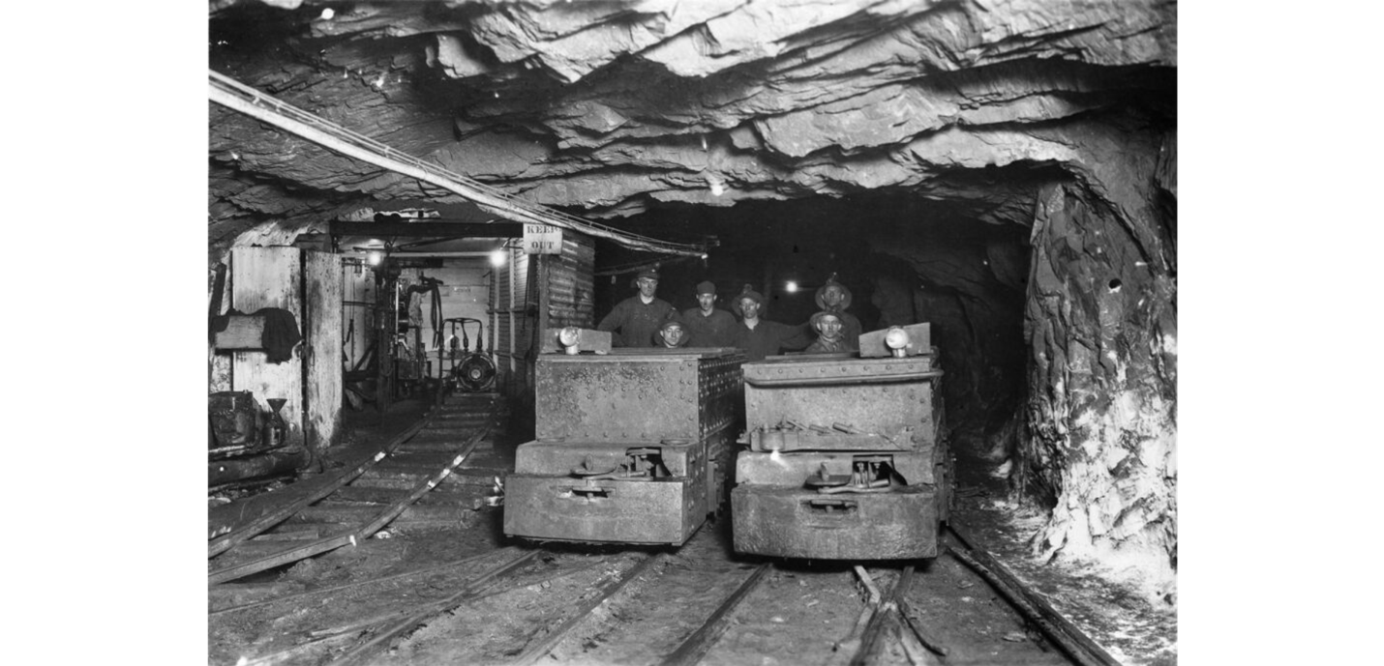
Figure 5. Electric Storage Battery Locomotives in a Republic Mine drift, 1920.
The second machine that Cleveland Cliffs used to move ore out of the mine were trams which were small carts (Figure 5) that transported ore from the location it was dislodged, through drifts, to the Pascoe Shaft. In 1919, Cleveland Cliffs upgraded their trams by purchasing and installing “electric storage battery locomotives.” The trams’ electric motor was more efficient than the previous tramming system, so the company claimed, “If we did not have the motor, we would have to employ six to eight additional trammers on each shift” to bring ore to the shaft. This shows that technological innovation at the Republic Mine increased efficiency; fewer miners could transport a greater volume of ore to the surface. This cut costs at the mine, allowing Cleveland Cliffs to increase profit.
This discussion of trams reveals that workers were required to operate the extractive technological systems. In addition to the “trammers” that operated trams, Cleveland Cliffs hired workers to operate each component of the Republic Mine’s vertical geography. “Miners” physically dislodged ore from ore bodies. “Rock pickers” sorted out and discarded low grade ore from dislodged piles of rock. “Cage Riders & Skiptenders” oversaw the skips of ore hauled up the shaft by the hoist. Moreover, attempts by management to increase labor efficiency was not confined to trammers with the advent of electric trams; Cleveland Cliffs attempted to increase labor efficiency across all positions. After cutting 85 jobs in 1914, productivity rose from 1.25 to 1.83 tons of ore extracted per worker per day over the course of that year. The company worked to extract more ore with fewer men which both increased revenue and cut costs with the overall effect of increasing profits. The move to increase profits reveals an additional role market logics played in mine development: markets were not only concerned with extracting the maximal amount of ore from the Republic Mine, they also required that Cleveland Cliffs extract that ore as efficiently as possible.
This analysis of the Pascoe Shaft reveals how the Republic Mine’s vertical geography worked: ore was moved, using technology operated by workers, through the mine from iron ore deposits to the surface. Innovating this system allowed Cleveland Cliffs to overcome technological limits and extract ore more efficiently. Geologic knowledge guided where technology and mining techniques would be employed to extract high-grade ore. Additionally, markets that were horizontally connected to Republic demanded that technological limits were overcome to extend the mine deeper and that Cleveland Cliffs operate the mine as efficiently as possible. Markets determined the value of the Republic Mine based on their decision to buy its ore; by reworking the vertical geography, Cleveland Cliffs continued to send a competitive product to markets. This system indicates that Cleveland Cliffs viewed Republic as a resource: the goal of Republic’s vertical geography was to extract as much profit from the mine as possible. However, this was a structural problem engrained in market logics that presupposed any one company — at the heart of extraction was the view that Republic was a mere resource that could be exploited by whichever company owned it for profit.
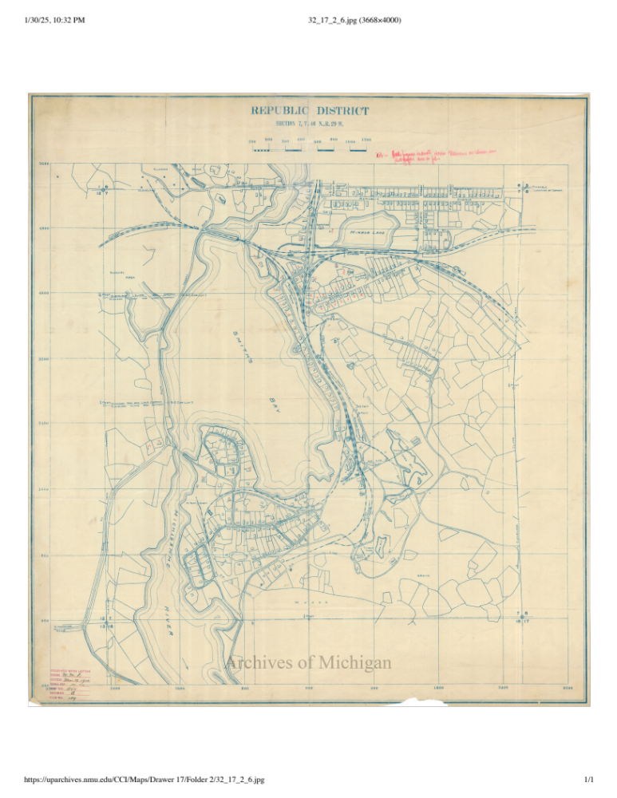
Figure 6. Map of Republic, 1921.
By the 1920s, a new horizontal and vertical geography took hold in Republic. This is evident by comparing Figure 2 with Figure 6: instead of just proposed railroads, maps of ore locations, and the idea for a mine, Figure 6 shows a mine with access to ore bodies, served by railroads, and surrounded by homes that house workers. Omitted from this map, but still present, were the mine shafts, drifts, and stopes that extended beneath Republic constituting its vertical geography. Analysis of this new geography admitted two key findings. The first is that the vertical and horizontal geographies augmented each other; as the horizontal geography intensified, so too did the vertical geography, and vice versa. The second is that market signals, technological advancement, and scientific knowledge guided mine development; markets demanded that geologists map out the ever deepening location of ore bodies to determine where to mine, and technology enabled a vertical geography in which ore dislodged deep underground could be brought to the surface. The vertical and horizontal geographies worked together to empower Cleveland Cliffs by extracting ore and sending that ore to markets where it was assigned value. However, as vertical and horizontal geographies further augmented each other to drive the mine deeper, development of new technology stalled, resulting in mine closure. This would undermine the empowered Cleveland Cliffs in Republic.

Depletion and Renewing Geographies (1925–1950)
In 1925, the Republic Mine released a dire warning. That year, the company’s annual report stated, “The situation at the Republic Mine is very critical and unless we discover new ore bodies during the year, the mine will have to be abandoned.” Over the next year, new ore bodies were not found, and management recommended “that the mine be closed in the early summer so that the men can move their families and find employment elsewhere before winter.” In 1927, Cleveland Cliffs began disassembling the mine, and on May 21, 1928, the Republic Mine officially closed., Even though complex vertical and horizontal geographies served the Republic Mine — enabling the extraction and shipment of increasingly deep ore bodies — the mine still closed. Perhaps this result seems inevitable, as Mumford states, “The mine owner… is constantly consuming his own capital” by operating the mine. Since by the time the mine closed, it sat 2,840 feet deep — or over a half-mile — less ore was available to extract. Cleveland Cliffs, it would seem, depleted their capital, forcing the mine to close.
However, the idea that the mine inevitably closed because there was no ore left for Cleveland Cliffs to mine is wrong for three reasons. The first is that there was still known ore reserves, they were just not accessible to Cleveland Cliffs. The second reason is that expenses were becoming too high to continue extending the mine shaft deeper into the earth in search of new ore reserves. The third reason is that closure did not just happen instantaneously on May 21, 1928; instead, the extractive logic that guided the mine’s horizontal and vertical development throughout its lifespan contributed to its closure. All these explanations suggest that the mine did not close because of geologic limits in the mine’s vertical geography. Rather, the complex relationship between vertical and horizontal systems, shaped by decisions Cleveland Cliffs made, ultimately caused the Republic Mine to close. After the mine closed, Cleveland Cliffs left behind unused mineshafts and railroads. While mining was abandoned, the horizontal geography was transformed to support automobile roads which connected spatially dispersed miners to other mine locations for work.

Forces of Depletion
Geologic reports from the Republic Mine obfuscated the role of markets in the mine’s closure. In 1925 and 1926, reports from the mine informed management that geologists were not discovering new ore bodies. For example, in 1926, geologists performed “an extensive exploration campaign,” but “very little ore was proved up.” Management recommended that the mine be closed in 1926 due to the lack of new ore discoveries. However, Cleveland Cliffs admitted, “How long we can continue to operate the Republic Mine is entirely dependent on the costs we can obtain.” While geologic realities inhibited mine development, markets — and the costs they could permit — determined when the mine closed. With this understanding, the following analysis will explore the market driven reasons for the Republic Mine’s closure.
In 1926, on the eve of the mine’s closure, Cleveland Cliffs knew of two ore deposits that the company did not attempt to mine due to high costs. The first was an untapped ore body along the Pascoe Shaft, near the surface. While Cleveland Cliffs discovered the deposit contained “a fair footage of ore, it [was] shallow and there [was] not sufficient tonnage to permit an extractive operation.” The company further elaborated that it was cost prohibitive to mine the ore body because “it would be necessary to install more permanent equipment” at a high cost. A combination of geologic knowledge and technology could have removed this ore body, but costs were too high to remove it profitably.
The second known ore deposits were “shaft pillars” of unmined ore that provided support to the mine’s ceiling. To remove the shaft pillars, Cleveland Cliffs would need to construct and install new wooden pillars for support and stop operations elsewhere in the mine to limit physical disturbances. Ultimately, the company concluded these factors made it impractical to mine the shaft pillars, citing “the cost of mining and conditions.” Once again, known ore reserves were left unmined by Cleveland Cliffs due to cost considerations. These concerns over costs suggest markets were the reason why known ore deposits were not mined; costs were deemed too high if they exceeded revenue which is decided by the price of ore in markets. While the failure to extract these known ore bodies could be viewed as a technological fault, Cleveland Cliffs claimed they had technology capable of extracting the ore. The technological shortcoming was that they could not efficiently extract the iron ore. This reveals that the ore bodies were unmined because mining technology could not meet market demanded efficiency.

Year | Cost Per Ton of Ore | Depth of the Pascoe Shaft (ft)
1915 | $1.621 | 2150
1916 | $2.013 | Not Available
1917 | $2.954 | 2272
1918 | $3.203 | 2372
1919 | $3.564 | 2372
1920 | $3.997 | 2472
1921 | $4.172 | Not Available
1922 | $2.784 | 2570
1923 | $3.766 | 2670
1924 | $4.844 | 2770
1925 | $4.335 | 2840
Table 1. Cost per ton of ore produced at the Republic Mine and the depth of the Pascoe Shaft, 1915–1925.
Cleveland Cliffs faced a second cost concern: as the mine shaft extended deeper, the cost of production increased. According to the company, they stopped sinking the Pascoe Shaft in 1926 because “stopes have become smaller in size with depth,” and by that year the ore body was “pinching out.” While these geological concerns play a large role in explaining why the Republic Mine stopped extending deeper, Table 7 gives an alternative explanation. Between 1915 and 1925, the per-unit cost of production at the Republic Mine increased by 167%. This increase is correlated to the mine’s increasing depth, which grew from 2,150 to 2,840 feet deep in that time. Because the time and fuel required to operate the hoists that hauled ore out of the mine increased as the mine deepened, increased costs of production were at least partially attributable to the mine’s depth. Thus, increased costs of production cut into Cleveland Cliffs’ bottom line and disincentivized further mine development.
Importantly, the logic behind the mine’s vertical development resulted in depletion just over 50 years after the Republic Mine opened. Republic’s horizontal and vertical geography augmented each other, accelerating the mine’s development. As the shaft rapidly descended into the earth, easily accessible ore deposits were quickly exhausted. Previous technological developments — such as the electric hoist and electric trams in the Pascoe Shaft — allowed mine development to continue to deeper levels, but by the 1920s technological advancements were no longer capable of supporting the mine’s unsustainable practices. Thus, the system of markets, geologic knowledge, and technology that supported the mine’s development collapsed causing the mine to close. With this longer view of mine development, blame for the Republic Mine’s closure appears to fall on the unsustainable extractive logics brought to Republic from markets.
Overall, geology was partially to blame for the Republic Mine’s closure — the
“easily accessible” ore reserves were exhausted when the mine closed in 1928. However, markets played a central role in mine closure because they decided costs were too high to remove the remaining known ore deposits or continue exploration. Moreover, markets forces dictated the intense extractive logics brought to Republic, rapidly depleting the mine’s resources. Underlying these market logics was the view that Republic was a mere resource. Thus, after the mine was exhausted, markets no longer viewed Republic as a valuable resource. However, Cleveland Cliffs and the State of Michigan would rework the town’s horizontal geography to continue deriving value from Republic.

The Transformation of Horizontal Geographies
After the Republic Mine closed in 1928, many miners still lived in the town of Republic but lost access to immediately proximate employment opportunities. Nevertheless, a local newspaper article from 1928, after the Republic Mine closed, reported, “A number of men were laid off at the Republic and given places at other Cleveland-Cliffs mines in the district.” Republic’s relative proximity to other mines on the Marquette Iron Range allowed displaced miners to find employment elsewhere with the advent of automobile roads to facilitate the movement of workers. Cleveland Cliffs supported automobile roads since, in 1933, the company negotiated with the state to relocate a state trunkline road — called M-45 and renamed to M-95 in 1937 — through Republic over land owned by the company. At the same time, the Republic Mine’s closure rendered the railroads through Republic obsolete. These dual pressures reworked Republic’s horizontal geography from one served primarily by railroads to one served by roads. The technological development of roads changed the functionality of Republic’s horizontal geography: railroads primarily hauled ore, but newer roads supported the movement of people.
Observers at the time understood that railroads were largely being replaced by roads. Discussing state trunkline roads in rural Michigan during 1937, the State of Michigan Director of the State Highway Planning Survey, Fred Taylor, said, “The trunk-line highways have taken over the function of railroads in so many field.” However, while Taylor acknowledged that roads were fulfilling the role railroads once served, he did not mention that roads operated differently than railroads because they fostered non-linear connections that collapsed the distance between rural places. Even though he did not mention that particular difference, Taylor remarked on another occasion that, “It will be well to see what are the effects on the use of the highways of the region’s business interests,” alluding to new ways mining and logging companies in the UP would utilize roads. In Republic, Cleveland Cliffs utilized M-95 to continue tapping the town’s labor force at numerous other operational mines.
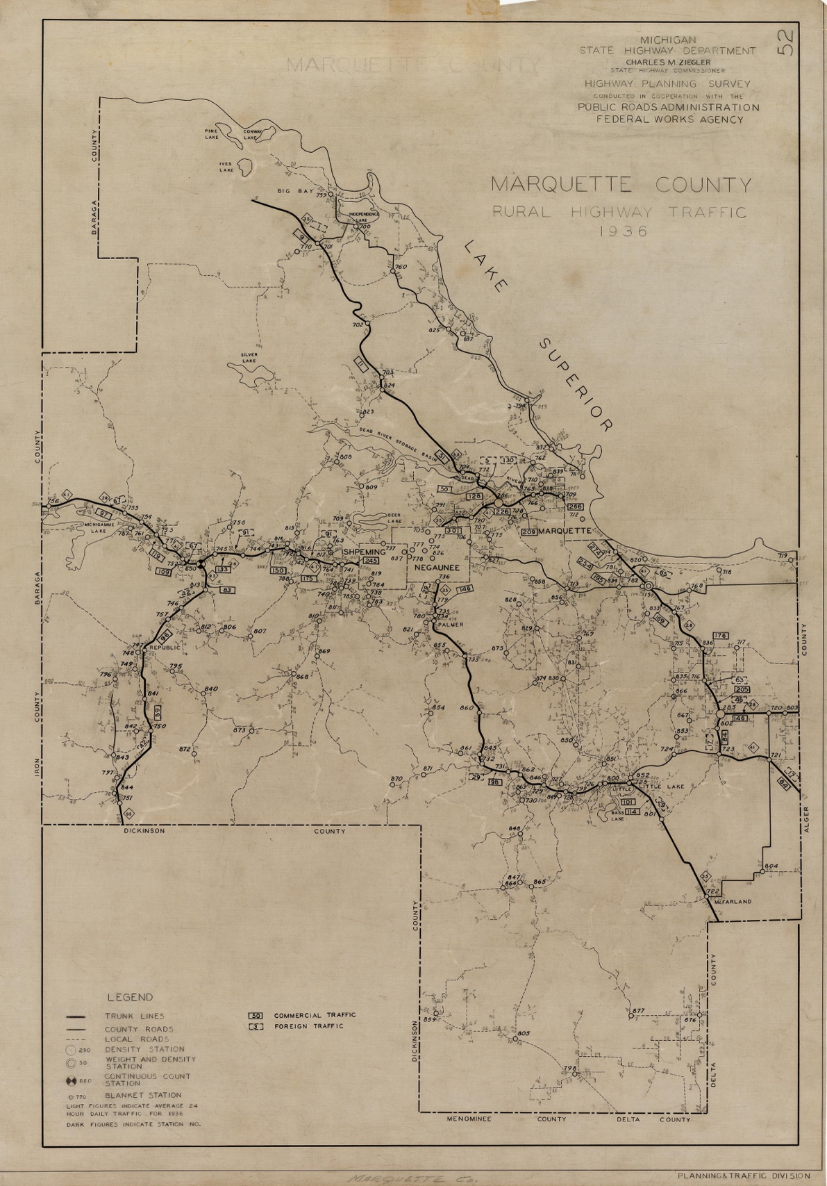
Figure 8. 1936 Map of Traffic Volumes in Marquette County
Analysis of traffic flow data from 1937 (Figure 8) demonstrates that M-95 did in fact connect workers in Republic to other mines on the Marquette Range. To travel to other regional mines from Republic, miners had to drive North on M-95 to US-41; the iron deposits of the Marquette Iron Range roughly followed the path of US-41 from Michigamme to Negaunee, so once at US-41, miners could travel in either direction to mines. According to Figure 8, average passenger vehicle traffic was around 300 cars per day South of Republic, and North of Republic, average passenger vehicle traffic flow jumped to about 425 cars per day. This demonstrates that people from Republic drove North to US-41, suggesting miners from Republic used M-95 to drive to work at other mines. This analysis was affirmed during World War II when the Michigan State Highway Department recognized, “The state’s… mining… industries are all largely dependent on highway transportation,” in part because, “75 percent of the employees of the state’s war industries go to and from their job by automobile,” with iron mining being one of the state’s war industries. Even after mine closure, Republic’s horizontal geography was reworked to support Cleveland Cliffs’ extraction of iron ore.
While Republic’s geography of extraction faced a crisis during the late-1920s as ore was depleted, Cleveland Cliffs asserted control to rework the horizontal geography. Instead of hauling ore, the new geography supported car travel which enabled miners in Republic to travel to work at other regional mines. However, this new geography continued to motivate Cleveland Cliffs to view Republic as a resource: roads connected the town to other mines, so Republic was seen as a reservoir of labor that could be employed elsewhere. However, not all workers were subject to the new horizontal geography after the Republic Mine closed — some workers were not given jobs at other Cleveland Cliffs mines. Without jobs in Republic, many workers left the town altogether. On the eve of mine closure in 1927, the company observed that workers were leaving Republic to find work “Out West.” Census figures corroborate this observation: Republic’s population dropped from 2,074 in 1920 to 1,422 in 1930. While it is unlikely that all miners left Republic after the mine closure, the 234 workers employed at the mine in 1920 account for the population decrease between 1920 and 1930. The township’s depopulation during this period suggests that for many residents, their only bond to Republic was through the mine.

Iron Ore Pellets and Intensified Geographies (1952–1980)
Before the Republic Mine closed, Cleveland Cliffs could only profitably extract high-grade ores that were shipped directly to markets. However, after the mine closed, there was still an abundance of low-grade jasper that had been overlooked. During the first half of the 20th century, new crushing and separation technologies were developed to process low-grade ores into high-grade “ore pellets.” This meant that the low-grade jasper reserves in Republic could be mined and converted into valuable pellets that markets were interested in buying. Jasper extraction necessitated a new mining system — open pit mining — which was larger in scale and more disruptive than shaft mining. After a low-grade ore mine and benefaction plant were constructed in Republic throughout the 1950s, the new technology affected Republic’s geography in two ways. First, after markets decided extraction of low-grade ore from Republic was profitable, Cleveland Cliffs rearticulated the town’s horizontal geography of extraction to re-connect Republic to markets. Second, the new mining technology reworked the vertical geography through open pit mining methods which intensified the scale of extraction in Republic. In the end, technology enabled mining to resume with a more pronounced effect on Republic’s landscape.

Rearticulating Previous Horizontal Geographies
Following World War II, most of the high-grade iron ore in the Lake Superior Iron District had been extracted. Needing to fuel both American industry and military development during the Cold War — both reliant on iron ore to make steel — American iron mining companies solved the depletion problems in two ways: they invested in high-grade foreign ore reserves and they developed iron ore refinement technology to access abundant domestic low-grade ore reserves. While the former required a new, global horizontal geography of extraction to connect distant ore reserves with America, the latter only required the rearticulation of railroads that previously served high-grade domestic mines. After Cleveland Cliffs became interested in developing a low-grade ore mine in Republic, the company needed to rebuild railroad lines, connecting the mine to markets that were ready to buy Republic’s ore.
In 1952, Cleveland Cliffs scouted Republic as a prime location for a low-grade ore mine and beneficiation plant. The company began planning the new mine in Republic because “it [appeared] as though the Republic ore body [was] the most desirable to develop at [that] time,” due to the large quantity of known ore reserves. After making plans for an open pit mine and concentration plant on the site, Cleveland Cliffs built a new railroad line to the mine location. This process resembled the extension of the railroad branch to Republic 80 years earlier; before extraction could begin, the mining company needed to have a method of transporting iron ore from the mine to markets. The new railroads were a rearticulation of the old ones in two ways.
First, the railroad effectively connected the mines to markets. From the moment the mine opened, its steel company partners served as the mine’s market. While Cleveland Cliffs operated the Republic Mine, it only owned 47.5% of the mine. The remaining 52.5% ownership stake was shared by a group steel companies in the Lower Great Lakes region, including Inland Steel, Jones & Laughlin, Wheeling Steel, and International Harvester. These steel company partners shipped ore extracted from the Republic Mine to their regional steel mills.
Second, the new railroad augmented the mine’s vertical geography. The new Republic Mine and beneficiation plant required far more machinery than the original mine needed in the 1870s, so the railroad transported construction materials to the mine. This demonstrates how in the second iteration of the Republic Mine, the vertical and horizontal geographies continued to augment each other: technological advancements that gave the Republic Mine newfound value brought in a new railroad line, and the new railroad line would be responsible for bringing the construction material necessary to extract ore from the new mine. With the railroad branch constructed, mining could commence at the new Republic Mine.

Reworked Vertical Geography
The new mining operation in Republic used different techniques and was larger in scale than the previous shaft mine. Manufacturing iron ore pellets necessitated a high level of extraction from the Republic Mine. For example, in 1957, the first year of full production at the mine, Cleveland Cliffs produced 323,860 tons of iron ore concentrate — an order of magnitude greater than production from the Republic Mine before 1928. To produce this amount of concentrate, the mine extracted 670,240 tons of low-grade jasper. As a result of these intense practices, the pit mine was over a mile in diameter, required massive machines, and completely reshaped Republic’s landscape. The pit was enabled by new mining technology that supported stripping rock from the earth’s surface and refining that rock into marketable ore. The large-scale extraction enabled by refinement technology led to an intensified vertical geography that brought about environmental destruction.
Extraction at the new Republic Mine commenced in two phases: stripping and pit mining. The first of these phases, stripping, removed the earth atop low-grade ore bodies. To do this, a dragline excavator, which consisted of a massive bucket connected to a crane, skimmed the earth’s surface to remove large amounts of earth at once. Stripping created a pit that occupied a much greater area than the previous shaft mine. In fact, the dragline excavator had to be careful to not fall into the old mine’s shafts and stopes; in one case, the “shaft pit… was filled” so the dragline excavator could stand on top of the old shaft and remove the surrounding overburden. The new pit mine subsumed the old mineshaft, removing the earth that was untouched during previous rounds of extraction.
After miners removed the overburden, Cleveland Cliffs began the physically intense process of pit mining. First, a jet piercer drilled holes into the low-grade ore bodies, then explosives were lowered into those holes. The blasts dislodged rock from the ore body, enabling a mechanical shovel to scoop up rocks and load them into trucks. These trucks would then bring the dislodged, low-grade ore to the crushing and concentrating plants where jasper was refined into high-grade ore pellets. Everything about this process, from the use of massive mechanical shovels to the industrial refining plant, is indicative of highly intense mining practices. To compare the intensity of pit mining to shaft mining in Republic, consider the mechanical shovel. The mechanical shovel used at the Republic Mine pit operation could remove 5 cubic yards of ore at once. Its scale was orders of magnitude larger than the (approximately) 5 cubic inch human hands (or the relatively small manual shovel miners used) that loaded ore onto trams, then onward to skips in the shaft mine. This one example is illustrative of a larger theme of intensified extractive technologies that enabled the new pit mine to subsume the old shaft mine. New technology intensified the scale of extraction at the Republic Mine.
In addition to being more intense, open pit mining methods were far more environmentally destructive than shaft mining. In the mid-1950s, Cleveland Cliffs removed entire neighborhoods of homes in Republic that were situated on top of the ore body to make way for the pit mine. The company platted a completely new town from scrap — which was called South Republic — and built new streets, sewers, and other infrastructure to support those displaced by the open pit mine. After South Republic was laid out, Cleveland Cliffs moved a total of 47 homes between 1955 and 1958. The company’s ability to move half of the town of Republic to a new location demonstrates Cleveland Cliffs’ enduring view of Republic as a resource: only interested in access to iron ore reserves, the company displaced many people to continue extraction. This view was also witnessed by the fact that a 5-mile section of M-95 was rebuilt to bypass the mine site in 1958. Cleveland Cliffs was able to rework the horizonal geography, removing all obstacles in the way of the new and intensified Republic Mine to maximize ore extraction.
New technology brought the shuttered Republic Mine back to life in 1956. This new technology changed the physical structure of mining in Republic, replacing the old tunnels through the earth with an intensified pit. On the other hand, Republic’s horizontal geography was rearticulated from previous eras of mining; new railroads branched to Republic as markets once again valued the mine’s low-grade ore. Moreover, these new horizontal geographies continued to augment the vertical geography. However, these intensified mining practices were only one solution to the depletion crisis facing regional iron ore mines after World War II. At the same time, foreign iron mines, with more ore readily available, were also connected to American markets. The initial success of the Republic Mine shows that, at first, Republic was competitive with iron ore imports. However, in subsequent years, this relationship would change.

Global Pressures, Local Crisis (1981–1996)
Throughout the Republic Mine’s history, a combination of market interest and technological advancement kept the mine open. This system was predicated on the fact that extracted iron ore could travel by railroads and freighters to regional markets where Cleveland Cliffs could trade iron ore for a profit. During the 1980s, there were two market vulnerabilities that the Republic Mine faced. The first vulnerability was that the Republic Mine only served regional markets; therefore, if the Great Lakes steel industry failed, so too would the markets that Republic’s ore served. The second vulnerability was globalization; Republic’s ore competed with ores from foreign countries that were oftentimes cheaper and capable of undercutting Republic’s production. In the 1980s, both vulnerabilities became reality at once. By 1996, the Republic Mine closed for good.

Market Crisis
The first vulnerability that the Republic Mine faced was the American steel crisis of the 1980s in which the domestic steel market collapsed. While this devastated the market to which the Republic Mine sold its iron ore pellets, more importantly, the steel crisis affected the steel company partners of the Republic Mine. In 1980, ownership of the Republic Mine was shared between Cleveland Cliffs, Wheeling Steel, Jones & Laughlin, and International Harvester. Cleveland Cliffs operated two other mines on the Marquette Iron Range in the early 1980s — the Empire Mine and the Tilden Mine — which were also owned by a similar combinations of steel companies. These partnerships were supposed to protect the mines as Cleveland Cliffs assumed, “If one partner failed, the other partners would save the partnership by buying a larger percentage of the mine.” This assumption was tested when two Great Lakes steel companies that held a stake in Marquette Range mines filed for bankruptcy in 1981: McLouth Steel in Detroit and International Harvester’s subsidiary Wisconsin Steel in Chicago. These bankruptcies forced Cleveland Cliffs to idle all mines on the Marquette Iron Range for multiple months in late-1980. The Republic Mine would never reopen from this mass idling of Marquette Range Mines.
The catastrophic market signals of the American steel crisis were believed to be caused by foreign steel imports. On the eve of these bankruptcies in 1980, Dr. Terry Monson addressed these pressures at the appropriately titled “Foreign Imports Dinner,” attended by mining union officials and the Marquette Range state representative, among other attendees. Monson addressed the “fact that imports are challenging our basic midwestern industries” of steelmaking. This framing suggests a perceived conflict between regional and global markets. This conflict is evinced by the fact that, according to Monson, Japanese steel costed on average “$50-100 per ton” less to produce, and transportation to the US was not cost prohibitive given the enhanced global supply chains following World War II. While Monson focused on the differences in cost between American and foreign steel, he also acknowledged the role that technology played in differentiating the two markets. He claimed that American steel mills were on average “older, smaller, and more likely to be technologically obsolete than foreign steel mills,” revealing that in 1980, people understood there was a technological component to the American steel crisis. These technological pressures, in the face of new global trade networks, meant that American markets were undercut by their foreign counterparts.
The Republic Mine’s age and location contributed to the mine’s permanent closure in the wake of these steel market pressures. Before the end of 1981, operations resumed at the other two Marquette Iron Range mines but not at the Republic Mine. Horizontally, the mine was farther away from the port at Marquette than the Empire and Tilden Mines, so ore had to be transported greater distances at a presumably higher cost. Vertically, the Republic Mine was the oldest of the three operational mines. After 24 years of operations, the mine’s older technology and depth likely made extraction at the Republic Mine less efficient than at other mines. While the publicly available historic record does not clearly state why production at the Republic Mine did not resume, these horizontal and vertical pressures likely increased the cost of production and made the Republic Mine uncompetitive. The market weakness of the mine was further evinced by the fact that partners began selling their shares; by the end of 1983, Cleveland Cliffs had complete ownership of the Republic Mine.

Shifting Global Trade Winds
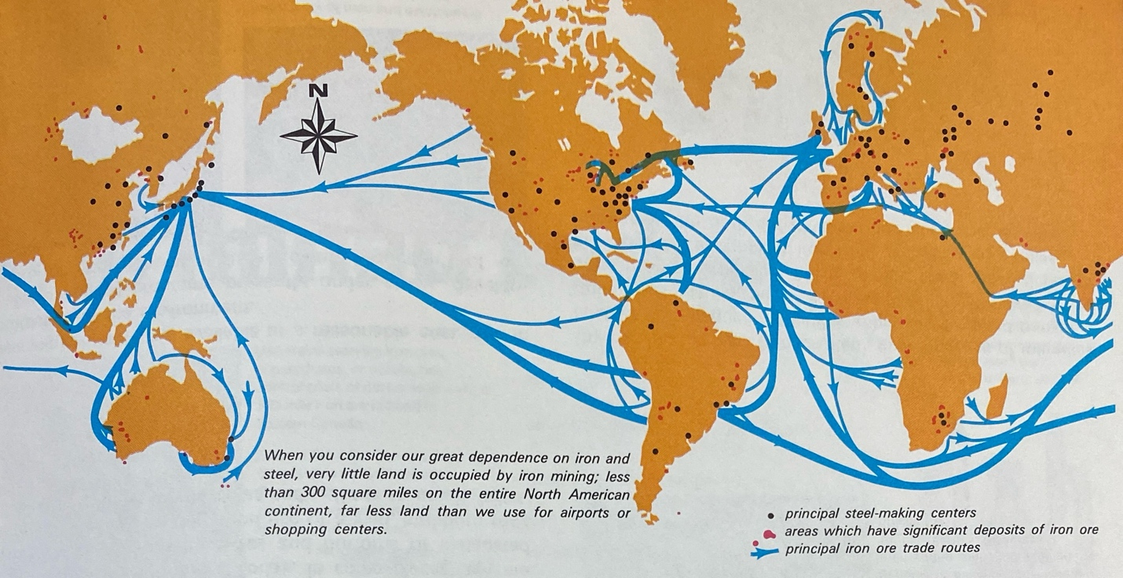
Figure 7. Map Showing Iron Ore Trade Routes and Volumes, 1970s.
The failure of the American steel industry was not solely responsible for the closure of the Republic Mine. On the eve of the crisis, in the 1970s, a booklet documenting iron ore mining showed shifting global trade winds. A chart on the first page of the booklet showed that iron ore production following World War II in the United States was relatively constant, while South America and Asia saw extreme growth. Between 1950 and 1970, American ore production dropped from 98 million tons to 90 million tons; in Asia, on the other hand, ore production increased from 5.3 million tons to 255 million tons in that same period, and likewise in South America, extraction increased from 3.2 million tons to 119 million tons. This suggests there was a new global geography of extraction in which mines were spatially dispersed around the globe. To support these globally dispersed mines, shipping lanes between continents linked mines to American markets. The same booklet included a map (Figure 8) that documented the emerging global trade flow of iron ore; instead of just a regional map of the Great Lakes, this map shows commercial flows crossing oceans and jumping between continents. This booklet did not think new commercial trends would be precarious for the American mining industry, instead seeing global trade as beneficial to “averting possible shortages in iron and steel.” However, the negative effects of the new global horizontal geography were soon to become apparent.
Global ore markets undercut the price of iron ore extracted from the Republic Mine. This concern was addressed by Dr. Monson at the “Foreign Imports Dinner” when he argued that, “Brazil and Venezuela… have lower costs because their richer ore requires less processing than ours and their average wage rate is about one-half that in the USA.” In addition to cheaper extraction costs, foreign ore from Brazil could travel to the East Cost at a comparable cost to shipments from Lake Superior to the Lower Great Lakes. This together meant that the new global geography of extraction — with cheaper ore abroad and more efficient trade routes — could outcompete the regional trade systems built to serve Republic’s ore. As steel companies shifted to buy ore from foreign mines, the Republic Mine lost its market which was already diminished following the numerous bankruptcies endured by American steel producers.
Cleveland Cliffs’ political behavior during the 1980s further illuminates how foreign trade contributed to the decline of extraction in Republic. In 1987, Cleveland Cliffs pushed the local state representative to introduce legislation supporting a tax break for the company. The legislation, House Bill 4775, would calculate the taxes on certain company properties based on global ore prices. With this legislation Cleveland Cliffs would face a lower tax burden — contributing to lower operational costs — the years that ore prices were low, effectively blunting the disruption brought by foreign trade. While the bill was passed in early 1988, it was too late to save the Republic Mine. Before the tax bill was even proposed, by the end of 1986, the company acknowledged that it would not be resuming operations at the Republic Mine because it was “no longer economically feasible” due to the deterioration of equipment that occurred while the mine was idled. After being closed so long, momentum resisted the mine’s reopening even with measures to mitigate the negative pressures of foreign imports.
The 1980s were an intense period of crisis in Republic. This crisis played out on two scales: the global scale, whose markets initiated the period of crisis; and the regional scale, whose markets were undermined by global markets. This period of crisis was caused by the globalized post-World War II geography. Foreign competition, linked horizontally to American markets, undercut domestic iron ore extraction and steel production which left the company without a market. The company was unable to profitably operate the Republic Mine, disposing it and looking to operate profitably elsewhere — Republic was no longer seen as a valuable resource to markets or Cleveland Cliffs. In this second and final mine closure, Republic’s vertical geography had very little relation to the halting of operations. While the Republic Mine was less competitive than the Empire and Tilden Mines, in part due to its age — and therefore its depth and the efficiency of its technology — there was no sign that Republic’s low-grade jasper reserves were near exhaustion when the mine closed. Instead, market conditions disincentivized production at the Republic Mine.

Conclusion
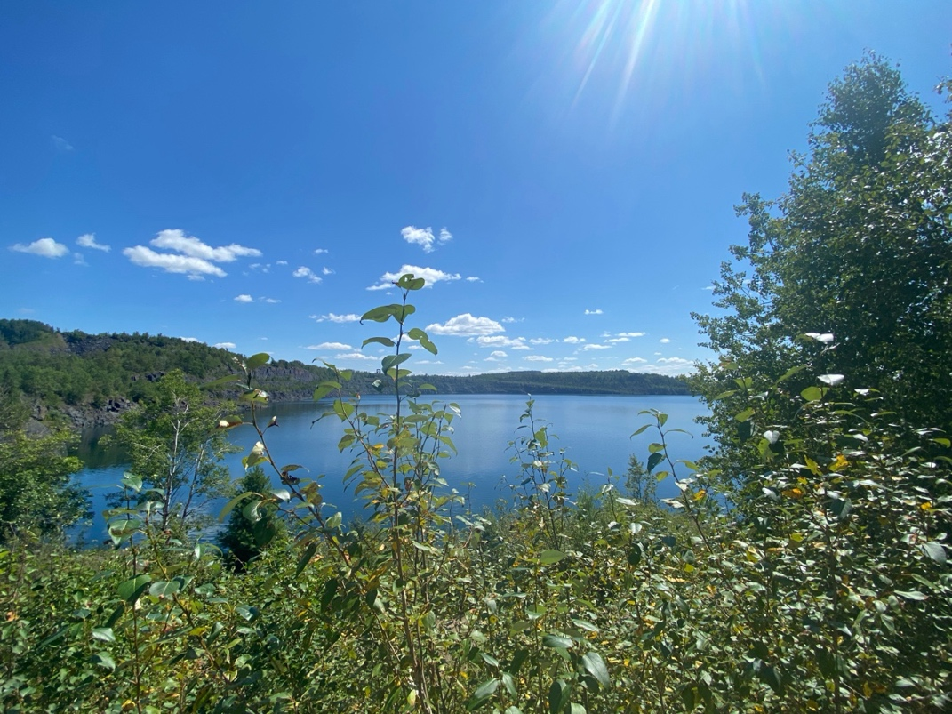
Figure 8. Photo of the (now abandoned) Republic Mine site, August, 2024.
Today, if you look at Republic on a map, the first thing you will see is the over one-mile-wide former open pit mine, now filled with water; it is the scale of a crater from a meteor strike, but humans made the pit. Next to the pit is downtown Republic — if you could call it that — which is mostly an open, grassy field, with a couple shops. Those shops include a gas station with just two pumps (probably from the 1970s), a corner store advertising a large and faded mountain dew sign, a seedy-looking bar with one or two cars parked out front at nearly all hours of the day, a small diner that specializes in cudighi sandwiches, and the post office. The Republic Bank, which one may expect to be filled with the riches extracted from the over one-mile-wide and thousands-of-feet-deep Republic Mine, is unfortunately closed. It was converted into a museum commemorating the town. The town may not be rich in money, but it is rich in heritage — for what that is worth. Across the mine pit from downtown is South Republic which is still separate from the town of Republic despite the mine being closed. South Republic hosts the school — with an unusual four-day school week to cut costs — a senior home, and a hardware store. In between Republic and South Republic is the former pit mine with a decaying observation tower overlooking the former mine site (Figure 8). Republic seems to be trapped in the past: forgotten, left behind, or just downright unable to reap the riches its minerals fostered.
The demographics of Republic are also stark. Between 1980, when the mine closed, and 2020, Republic’s population has decreased from 1,390 residents to 994 — nearly a 30% drop. Moreover, in that time the median age has increased from 35.4 to 59.1 years old; given that the state’s average age is 40.5 years old, these data indicate a critically aging population. The economic well-being of Republic’s residents is also discouraging, with a median income of just above $41,000, compared with a state median of nearly $70,000. By all accounts, the current state of Republic is not befitting of a town that brought so much material wealth to the world.
Republic faces these aesthetic and demographic challenges because the mine closed in the one-company town. While unclear at the time, the mine’s closure was due to the logics that guided extraction during the 1800s and 1900s in the United States. Land was reworked, in both a horizontal and vertical sense. Horizontally, land was seen as a canvass on which new trade routes could be constructed by reimagining bodies of water, developing railroads, and building automobile roads. Vertically, land was seen as a reservoir of commodities to be extracted and brought to markets. These two orthogonal geographies augmented each other to produce large profits. However, they also augmented each other to deplete finite ore reserves. On multiple occasions, technological limits were overcome to continue extracting iron ore from the mine in the face of alleged depletion. However, underlying each of these advancements was the enduring view of Republic as a resource. This view, held by markets, pushed Republic to maximize ore extraction at the lowest cost. When Cleveland Cliffs could no longer cost efficiently extract ore, the replaceable nature of resources meant that markets quickly moved on and Cleveland Cliffs abandoned the mine.
Though the mine is closed, and the current socioeconomic state of Republic seems weak, there are signs of hope. While on some logging roads around Republic your compass will point 15 degrees off North due to the still rich iron deposits in the ground, the days of extraction are over — this is not the hope you will find in Republic. Instead, nestled between rocky hills and swampy lowlands, Republic holds a unique heritage and culture that residents work to preserve. The landscape is dotted with interpretive signage placed by the Republic Historical Society, multiple church bells still ring on Sunday mornings, and community members have cultivated gardens on vacant land. The town’s distinct culture is preserved as Republic is one of the few places in the United States that has not adopted the standard American dialect in the past 75 years — people in Republic are harsh on their vowels, say “da” instead of “the”, and they end every question by asking “eh?”. The sense of community and resiliency that characterizes Republic points to a positive future.
However, these signs of hope are meaningless unless we each begin to care about Republic. The town’s future cannot be built exclusively from within; Republic’s resources were literally hollowed out to build cities, communities, and homes throughout the United States. Now, we are indebted to Republic and must help build the town’s future. Otherwise, we continue to support the same extractive culture and logics that relegated Republic to a mere resource.

Bibliography

Primary Sources

Annual Report, Chicago, Milwaukee, and St. Paul Railway Company, University of Chicago Library Circulation, Chicago, IL.
Castle, Owen. Map of the Marquette Iron Range. Created using QGIS and Google Earth Imagery. April 2025.
Cleveland Cliffs Company Records, Central Upper Peninsula and Northern Michigan University Archives, Marquette, MI.
Cleveland-Cliffs Inc. "Iron Ore Facilities." Accessed April 8, 2025. https://www.clevelandcliffs.com/operations/steelmaking/iron-ore-facilities.
Iron Trade Review, ed. The Lake Superior Iron Ore Annual: 1913- Official Figures on Shipments by Mines, Ranges and Ports Together with Complete Statistics Bearing on the Lake Superior Ore Movement since 1844. Ore Prices, Receipts at Lower Lake Docks. Cleveland: The Penton Publishing Co, 1913. https://catalog.lib.uchicago.edu/vufind/Record/2923807?sid=74169880.
Jacobetti Papers, Central Upper Peninsula and Northern Michigan University Archives, Marquette, MI.
Kohn, Steven Mark. Red Iron Ore. 2000. Song of America. https://songofamerica.net/song/red-iron-ore/.
Map Collection, Archives of Michigan, Lansing, MI.
Mining Journal Archives, Peter White Public Library, Marquette, MI.
Records of the Michigan State Highway Department. 1916-1952 (bulk 1933-1949), Archives of Michigan, Lansing, MI.
Republic Township Planning Commission. Republic Township Master Plan: 2024–2029. Republic, MI: Republic Township Planning Commission. https://www.republicmichigan.com/boards-and-committees/planning-commission/master-plan-2024-2029/.
U.S. Department of Commerce. 1930 Census of Population: Volume 1, Population of the United States. U.S. Government Printing Office, 1931. https://www.census.gov/library/publications/1931/dec/1930a-vol-01-population.html.

Secondary Sources

Cronon, William. Nature’s Metropolis: Chicago and the Great West. New York: W.W. Norton, 1991. https://catalog.lib.uchicago.edu/vufind/Record/1128770?sid=74106388.
Iron Trade Review, ed. The Lake Superior Iron Ore Annual: 1913- Official Figures on Shipments by Mines, Ranges and Ports Together with Complete Statistics Bearing on the the Lake Superior Ore Movement since 1844. Ore Prices, Receipts at Lower Lake Docks. Cleveland: The Penton Publishing Co, 1913. https://catalog.lib.uchicago.edu/vufind/Record/2923807?sid=74169880.
Manuel, Jeffrey T. Taconite Dreams : The Struggle to Sustain Mining on Minnesota’s Iron Range, 1915-2000. Minneapolis; London: University of Minnesota Press, 2015. https://research.ebsco.com/linkprocessor/plink?id=6bb42298-08b3-3be1-8380-6316c0dc4384.
McNeill, John Robert, and George Vrtis, eds. Mining North America: An Environmental History since 1522. Oakland, California: University of California Press, 2017. https://catalog.lib.uchicago.edu/vufind/Record/11445639?sid=74126996.
Meints, Graydon M. Michigan Railroad Lines. East Lansing: Michigan State University Press, 2005. https://catalog.lib.uchicago.edu/vufind/Record/5614942?sid=74167628.
Mumford, Lewis. “Technics and Civilization.” ACLS Humanities E-Book, 1934. https://catalog.lib.uchicago.edu/vufind/Record/10514442?sid=73854521.
Ottke, Doug. “An environmental history of the 19th century Marquette Iron Range.” Open-File Report, January 1, 2000. https://research.ebsco.com/linkprocessor/plink?id=819a16fc-3ea2-3e42-8f76-dacba3b600c0.
Reynolds, Terry S. “‘Destined to Produce [a] … Revolution’: Michigan’s Iron Ore Industry in the Civil War.” Michigan Historical Review 39, no. 2 (2013): 21. https://doi.org/10.5342/michhistrevi.39.2.0021.
Reynolds, Terry S., and Virginia P. Dawson. Iron Will: Cleveland-Cliffs and the Mining of Iron Ore, 1847-2006. Great Lakes Books Series. Detroit: Wayne State University Press, 2011. https://catalog.lib.uchicago.edu/vufind/Record/11278527?sid=66909242.
Studnicki-Gizbert, Daviken. Exhausting the Sierra Madre: Mining Ecologies in Mexico over the Longue Durée. Mining North America: An Environmental History Since 1522. University of California Press, 2017. https://research.ebsco.com/linkprocessor/plink?id=c4a46918-8b45-3825-9eb5-cd6ff8c3d262.
Thistle, John, and Nancy Langston. “Entangled Histories: Iron Ore Mining in Canada and the United States.” The Extractive Industries and Society 3, no. 2 (April 2016): 269–77. https://doi.org/10.1016/j.exis.2015.06.003.
Vrtis, George. 3. A World of Mines and Mills: Precious-Metals Mining, Industrialization, and the Nature of the Colorado Front Range. Mining North America ; page 73-107. United States, North America: University of California Press, 2019. https://research.ebsco.com/linkprocessor/plink?id=6392b253-09ab-3de2-bf95-55dddea890e8.
Wells, Christopher W. Car Country: An Environmental History. Weyerhaeuser Environmental Books. Seattle: University of Washington Press, 2012. https://catalog.lib.uchicago.edu/vufind/Record/9035912?sid=74106286.
Wilson, Lisa J. “Riding the Resource Roller Coaster: Understanding Socioeconomic Differences between Mining Communities.” Rural Sociology 69, no. 2 (June 1, 2004): 261–81. https://doi.org/10.1526/003601104323087606.
Workman, R.D., M.P. Owens, C.L. Wolverton, and G.J. Goodman. “Creating Wetlands for Compensatory Mitigation by Reclamation of Iron Mine Tailings Basins at the Republic Mine in Marquette County, Michigan.” Journal American Society of Mining and Reclamation 2006, no. 2 (June 30, 2006): 2502–13. https://doi.org/10.21000/JASMR06022502.

John Robert McNeill and George Vrtis, eds., Mining North America: An Environmental History since 1522 (Oakland, California: University of California Press, 2017), 5–13, https://catalog.lib.uchicago.edu/vufind/Record/11445639?sid=74126996.
Jeffrey T. Manuel, Taconite Dreams : The Struggle to Sustain Mining on Minnesota’s Iron Range, 1915-2000 (Minneapolis; London: University of Minnesota Press, 2015), 220–23, https://research.ebsco.com/linkprocessor/plink?id=6bb42298-08b3-3be1-8380-6316c0dc4384.
Terry S. Reynolds and Virginia P. Dawson, Iron Will: Cleveland-Cliffs and the Mining of Iron Ore, 1847-2006, Great Lakes Books Series (Detroit: Wayne State University Press, 2011), 13–16, https://catalog.lib.uchicago.edu/vufind/Record/11278527?sid=66909242.
Cleveland-Cliffs Inc. "Iron Ore Facilities." Accessed April 8, 2025. https://www.clevelandcliffs.com/operations/steelmaking/iron-ore-facilities.
Reynolds and Dawson, Iron Will.
Cleveland Cliffs Iron Company. “Cleveland Cliffs Iron Company Mining Department Annual Report, 1928 (Part 3)”. Reports. Mining Department. Central Upper Peninsula and Northern Michigan University Archives. https://uplink.nmu.edu/node/49719.
Reynolds and Dawson, Iron Will, 181–83, 229.
Reynolds and Dawson, Iron Will.
Reynolds and Dawson, 84–138.
U.S. Census Bureau. 2020 Decennial Census, Table SO101: Age and Sex, Republic CDP, Michigan. Accessed April 8, 2025.
Lewis Mumford, “Technics and Civilization,” ACLS Humanities E-Book, 1934, 110, https://catalog.lib.uchicago.edu/vufind/Record/10514442?sid=73854521.
Mumford, 112.
Mumford, 123.
Mumford, 156–63.
Mumford, 151.
George Vrtis, 3. A World of Mines and Mills: Precious-Metals Mining, Industrialization, and the Nature of the Colorado Front Range, Mining North America ; page 73-107 (United States, North America: University of California Press, 2019), 79–80, https://research.ebsco.com/linkprocessor/plink?id=6392b253-09ab-3de2-bf95-55dddea890e8.
William Cronon, Nature’s Metropolis: Chicago and the Great West (New York: W.W. Norton, 1991), 81, https://catalog.lib.uchicago.edu/vufind/Record/1128770?sid=74106388.
Cronon, 92.
Christopher W. Wells, Car Country: An Environmental History, Weyerhaeuser Environmental Books (Seattle: University of Washington Press, 2012), 148, https://catalog.lib.uchicago.edu/vufind/Record/9035912?sid=74106286.
Wells, 154.
Wells, 157.
John Thistle and Nancy Langston, “Entangled Histories: Iron Ore Mining in Canada and the United States,” The Extractive Industries and Society 3, no. 2 (April 2016): 1, https://doi.org/10.1016/j.exis.2015.06.003.
Mumford, “Technics and Civilization,” 145.
Mumford, 158–63.
Mumford, 157.
Lisa J. Wilson, “Riding the Resource Roller Coaster: Understanding Socioeconomic Differences between Mining Communities.,” Rural Sociology 69, no. 2 (June 1, 2004): 261–62, https://doi.org/10.1526/003601104323087606.
Daviken Studnicki-Gizbert, Exhausting the Sierra Madre: Mining Ecologies in Mexico over the Longue Durée, Mining North America: An Environmental History Since 1522 (University of California Press, 2017), 21, https://research.ebsco.com/linkprocessor/plink?id=c4a46918-8b45-3825-9eb5-cd6ff8c3d262.
Wilson, “Riding the Resource Roller Coaster,” 5.
Wilson, 5–6.
Manuel, 7. Efficiency, Economics, and Environmentalism, 197–98.
Reynolds and Dawson, Iron Will, 69.
Manuel, 7. Efficiency, Economics, and Environmentalism, 201–5.
Lankton, Hollowed Ground, 85–89.
Studnicki-Gizbert, Exhausting the Sierra Madre, 19–38.
Reynolds and Dawson, Iron Will, 224–36.
Manuel, Taconite Dreams, 198–202.
Robertson, Hard As the Rock Itself, 79.
Lankton, Hollowed Ground, 5.
Map of Republic Mountain and Vicinity. Map. From Archives of Michigan, Map Collection. https://michigan.access.preservica.com/uncategorized/IO_461cfbb3-fd61-497d-befb-b2325699ba09/. (Accessed March 13, 2025).
Doug Ottke, “An environmental history of the 19th century Marquette Iron Range,” Open-File Report, January 1, 2000, 44–73, https://research.ebsco.com/linkprocessor/plink?id=819a16fc-3ea2-3e42-8f76-dacba3b600c0.
“An Ordinance for the Government of the Territory of the United States, Northwest of the River Ohio,” July 13, 1787.
Mumford, “Technics and Civilization,” 122–23.
Ottke, “An environmental history of the 19th century Marquette Iron Range,” 95–107.
Treaty with the Chippewa, 1842, Oklahoma State University Treaties, accessed March 13, 2025, https://treaties.okstate.edu/treaties/treaty-with-the-chippewa-1842-0542.
Reynolds and Dawson, Iron Will, 28–31.
Mumford, “Technics and Civilization,” 165.
Terry S. Reynolds, “‘Destined to Produce [a] … Revolution’: Michigan’s Iron Ore Industry in the Civil War,” Michigan Historical Review 39, no. 2 (2013): 28, https://doi.org/10.5342/michhistrevi.39.2.0021.
Cleveland-Cliffs Iron Company. “Cleveland-Cliffs Iron Company Mining Department Annual Report, 1928 (Part 4)”. Reports. Mining Department. Central Upper Peninsula and Northern Michigan University Archives. https://uplink.nmu.edu/node/29977.
Graydon M. Meints, Michigan Railroad Lines (East Lansing: Michigan State University Press, 2005), 15, https://catalog.lib.uchicago.edu/vufind/Record/5614942?sid=74167628.
Cronon, Nature’s Metropolis, 57.
Cronon, 81.
Cronon, 81–93.
Cleveland Cliffs Iron Company. “Cleveland Cliffs Iron Company Mining Department Annual Report, 1914 (Part 5)”. Reports. Mining Department. Central Upper Peninsula and Northern Michigan University Archives. https://uplink.nmu.edu/node/21140.
Cronon, Nature’s Metropolis, 81.
"Red Iron Ore," Song of America, accessed March 13, 2025, https://songofamerica.net/song/red-iron-ore/.
Chicago, Milwaukee, and St. Paul Railway Company. “Annual Report 1891”. University of Chicago Library Circulation. https://catalog.lib.uchicago.edu/vufind/Record/7251338?sid=74169010.
Chicago, Milwaukee, and St. Paul Railway Company. “Annual Report 1891”. University of Chicago Library Circulation. https://catalog.lib.uchicago.edu/vufind/Record/7251338?sid=74169010.
Chicago, Milwaukee, and St. Paul Railway Company. “Annual Report 1892”. University of Chicago Library Circulation. https://catalog.lib.uchicago.edu/vufind/Record/7251338?sid=74169010.
Chicago, Milwaukee, and St. Paul Railway Company. “Annual Report 1891”. University of Chicago Library Circulation. https://catalog.lib.uchicago.edu/vufind/Record/7251338?sid=74169010.
Chicago, Milwaukee, and St. Paul Railway Company. “Annual Report 1893”. University of Chicago Library Circulation. https://catalog.lib.uchicago.edu/vufind/Record/7251338?sid=74169010.
Iron Trade Review, ed., The Lake Superior Iron Ore Annual: 1913- Official Figures on Shipments by Mines, Ranges and Ports Together with Complete Statistics Bearing on the the Lake Superior Ore Movement since 1844. Ore Prices, Receipts at Lower Lake Docks (Cleveland: The Penton Publishing Co, 1913), 54–55, https://catalog.lib.uchicago.edu/vufind/Record/2923807?sid=74169880.
McNeill and Vrtis, Mining North America, 86–87.
Cleveland Cliffs Iron Company. “Cleveland Cliffs Iron Company Mining Department Annual Report, 1914 (Part 5)”. Reports. Mining Department. Central Upper Peninsula and Northern Michigan University Archives. https://uplink.nmu.edu/node/21140.
Republic Mine Geological Pascoe Shaft Section, Ely Township (2 Maps) 1928. Map. From Central Upper Peninsula and Northern Michigan University Archives, Cleveland Cliffs Iron Company Records: Historical Maps 1882-1937. https://uparchives.nmu.edu/CCI/Maps.html#toc. (Accessed March 13, 2025).
Cleveland Cliffs Iron Company. “Cleveland Cliffs Iron Company Mining Department Annual Report, 1914 (Part 5)”. Reports. Mining Department. Central Upper Peninsula and Northern Michigan University Archives. https://uplink.nmu.edu/node/21140.
Republic Mine Geological Pascoe Shaft Section, Ely Township (2 Maps) 1928. Map. From Central Upper Peninsula and Northern Michigan University Archives, Cleveland Cliffs Iron Company Records: Historical Maps 1882-1937. https://uparchives.nmu.edu/CCI/Maps.html#toc. (Accessed March 13, 2025).
Cleveland-Cliffs Iron Company. “Cleveland Cliffs Iron Company Mining Department Annual Report, 1919 (Part 5)”. Reports. Mining Department. Central Upper Peninsula and Northern Michigan University Archives. https://uplink.nmu.edu/node/65226.
McNeill and Vrtis, Mining North America, 27–29.
Cleveland-Cliffs Iron Company. “Cleveland Cliffs Iron Company Mining Department Annual Report, 1919 (Part 5)”. Reports. Mining Department. Central Upper Peninsula and Northern Michigan University Archives. https://uplink.nmu.edu/node/65226.
Cleveland-Cliffs Iron Company. “Battery Storage Locomotives – Republic Mine – Mechanical Department” Photographs. Photographs. Central Upper Peninsula and Northern Michigan University Archives. https://uplink.nmu.edu/node/65226.
Cleveland-Cliffs Iron Company. “Cleveland Cliffs Iron Company Mining Department Annual Report, 1919 (Part 5)”. Reports. Mining Department. Central Upper Peninsula and Northern Michigan University Archives. https://uplink.nmu.edu/node/65226.
Cleveland Cliffs Iron Company. “Cleveland Cliffs Iron Company Mining Department Annual Report, 1914 (Part 5)”. Reports. Mining Department. Central Upper Peninsula and Northern Michigan University Archives. https://uplink.nmu.edu/node/21140.
Republic District Section 15 T, 47 N., R27., Ishpeming 1921. Map. From Central Upper Peninsula and Northern Michigan University Archives, Cleveland Cliffs Iron Company Records: Historical Maps 1882-1937. https://uparchives.nmu.edu/CCI/Maps.html#toc. (Accessed March 13, 2025).
Cleveland Cliffs Iron Company. “Cleveland Cliffs Iron Company Mining Department Annual Report, 1925 (Part 4)”. Reports. Mining Department. Central Upper Peninsula and Northern Michigan University Archives. https://uplink.nmu.edu/node/82313.
Cleveland Cliffs Iron Company. “Cleveland Cliffs Iron Company Mining Department Annual Report, 1926 (Part 4)”. Reports. Mining Department. Central Upper Peninsula and Northern Michigan University Archives. https://uplink.nmu.edu/node/17066.
Cleveland Cliffs Iron Company. “Cleveland Cliffs Iron Company Mining Department Annual Report, 1927 (Part 3)”. Reports. Mining Department. Central Upper Peninsula and Northern Michigan University Archives. https://uplink.nmu.edu/node/4280.
Cleveland Cliffs Iron Company. “Cleveland Cliffs Iron Company Mining Department Annual Report, 1928 (Part 3)”. Reports. Mining Department. Central Upper Peninsula and Northern Michigan University Archives. https://uplink.nmu.edu/node/49719.
Mumford, “Technics and Civilization,” 157.
Cleveland Cliffs Iron Company. “Cleveland Cliffs Iron Company Mining Department Annual Report, 1925 (Part 4)”. Reports. Mining Department. Central Upper Peninsula and Northern Michigan University Archives. https://uplink.nmu.edu/node/82313.
Cleveland Cliffs Iron Company. “Cleveland Cliffs Iron Company Mining Department Annual Report, 1926 (Part 4)”. Reports. Mining Department. Central Upper Peninsula and Northern Michigan University Archives. https://uplink.nmu.edu/node/17066.
Cleveland Cliffs Iron Company. “Cleveland Cliffs Iron Company Mining Department Annual Report, 1926 (Part 4)”. Reports. Mining Department. Central Upper Peninsula and Northern Michigan University Archives. https://uplink.nmu.edu/node/17066.
Cleveland Cliffs Iron Company. “Cleveland Cliffs Iron Company Mining Department Annual Report, 1915 (Part 4)”. Reports. Mining Department. Central Upper Peninsula and Northern Michigan University Archives. https://uplink.nmu.edu/node/21345, Cleveland Cliffs Iron Company. “Cleveland Cliffs Iron Company Mining Department Annual Report, 1917 (Part 4)”. Reports. Mining Department. Central Upper Peninsula and Northern Michigan University Archives. https://uplink.nmu.edu/node/75083, Cleveland Cliffs Iron Company. “Cleveland Cliffs Iron Company Mining Department Annual Report, 1918 (Part 4)”. Reports. Mining Department. Central Upper Peninsula and Northern Michigan University Archives. https://uplink.nmu.edu/node/73213, Cleveland Cliffs Iron Company. “Cleveland Cliffs Iron Company Mining Department Annual Report, 1919 (Part 4)”. Reports. Mining Department. Central Upper Peninsula and Northern Michigan University Archives. https://uplink.nmu.edu/node/50861, Cleveland Cliffs Iron Company. “Cleveland Cliffs Iron Company Mining Department Annual Report, 1920 (Part 4)”. Reports. Mining Department. Central Upper Peninsula and Northern Michigan University Archives. https://uplink.nmu.edu/node/41812, Cleveland Cliffs Iron Company. “Cleveland Cliffs Iron Company Mining Department Annual Report, 1922 (Part 4)”. Reports. Mining Department. Central Upper Peninsula and Northern Michigan University Archives. https://uplink.nmu.edu/node/68664, Cleveland Cliffs Iron Company. “Cleveland Cliffs Iron Company Mining Department Annual Report, 1923 (Part 4)”. Reports. Mining Department. Central Upper Peninsula and Northern Michigan University Archives. https://uplink.nmu.edu/node/14667, Cleveland Cliffs Iron Company. “Cleveland Cliffs Iron Company Mining Department Annual Report, 1924 (Part 4)”. Reports. Mining Department. Central Upper Peninsula and Northern Michigan University Archives. https://uplink.nmu.edu/node/50440, Cleveland Cliffs Iron Company. “Cleveland Cliffs Iron Company Mining Department Annual Report, 1925 (Part 4)”. Reports. Mining Department. Central Upper Peninsula and Northern Michigan University Archives. https://uplink.nmu.edu/node/82313.
Cleveland Cliffs Iron Company. “Cleveland Cliffs Iron Company Mining Department Annual Report, 1926 (Part 4)”. Reports. Mining Department. Central Upper Peninsula and Northern Michigan University Archives. https://uplink.nmu.edu/node/17066.
“The Daily Mining Journal, 1928-05-23”. Newspapers. 05. May 1928. Marquette (Mich.): A. P. Swineford and Company, May 23, 1928. Peter White Public Library. https://uplink.nmu.edu/node/14708.
Cleveland Cliffs Iron Company. “Cleveland Cliffs Iron Company Mining Department Annual Report, 1933 (Part 3)”. Reports. Mining Department. Central Upper Peninsula and Northern Michigan University Archives. https://uplink.nmu.edu/node/20599.
“Highway Planning Information in Relation to Municipalities” by Fred C. Taylor, RG 58-5, Box 2, FC Taylor, Archives of Michigan, Lansing, MI.
Wells, Car Country, 148–57.
“The Highway Planning Survey as it Affects the Upper Peninsula” by Fred C. Taylor, RG 58-5, Box 2, FC Taylor, Archives of Michigan, Lansing, MI.
Marquette County Rural Highway Traffic-1936. Map. From Archives of Michigan, Map Collection. https://michigan.access.preservica.com/uncategorized/IO_aaec7dbb-a9cf-4f3f-8649-0e90f8acb8ac/. (Accessed March 13, 2025).
“Essential Highway Construction-1944” by the Michigan State Highway Department, RG 58-9, box 7, folder 9, Archives of Michigan, Lansing, MI.
Cleveland Cliffs Iron Company. “Cleveland Cliffs Iron Company Mining Department Annual Report, 1927 (Part 3)”. Reports. Mining Department. Central Upper Peninsula and Northern Michigan University Archives. https://uplink.nmu.edu/node/4280.
U.S. Department of Commerce, 1930 Census of Population: Volume 1, Population of the United States, U.S. Government Printing Office, 1931. https://www.census.gov/library/publications/1931/dec/1930a-vol-01-population.html.
Cleveland Cliffs Iron Company. “Cleveland Cliffs Iron Company Mining Department Annual Report, 1920 (Part 5)”. Reports. Mining Department. Central Upper Peninsula and Northern Michigan University Archives. https://uplink.nmu.edu/node/14459.
Manuel, Taconite Dreams, 1–32.
Thistle and Langston, “Entangled Histories,” 1–3.
Reynolds and Dawson, Iron Will, 180–83.
Cleveland Cliffs Iron Company. “Cleveland Cliffs Iron Company Mining Department Annual Report, 1953 (Part 2)”. Reports. Mining Department. Central Upper Peninsula and Northern Michigan University Archives. https://uplink.nmu.edu/node/46746.
Cleveland Cliffs Iron Company. “Cleveland Cliffs Iron Company Mining Department Annual Report, 1957 (Part 1)”. Reports. Mining Department. Central Upper Peninsula and Northern Michigan University Archives. https://uplink.nmu.edu/node/55181.
Cleveland Cliffs Iron Company. “Cleveland Cliffs Iron Company Mining Department Annual Report, 1957 (Part 1)”. Reports. Mining Department. Central Upper Peninsula and Northern Michigan University Archives. https://uplink.nmu.edu/node/55181.
Cleveland Cliffs Iron Company. “Cleveland Cliffs Iron Company Mining Department Annual Report, 1957 (Part 1)”. Reports. Mining Department. Central Upper Peninsula and Northern Michigan University Archives. https://uplink.nmu.edu/node/55181.
Cleveland Cliffs Iron Company. “Cleveland Cliffs Iron Company Mining Department Annual Report, 1957 (Part 1)”. Reports. Mining Department. Central Upper Peninsula and Northern Michigan University Archives. https://uplink.nmu.edu/node/55181.
Cleveland Cliffs Iron Company. “Cleveland Cliffs Iron Company Mining Department Annual Report, 1954 (Part 2)”. Reports. Mining Department. Central Upper Peninsula and Northern Michigan University Archives. https://uplink.nmu.edu/node/79800.
Cleveland Cliffs Iron Company. “Cleveland Cliffs Iron Company Mining Department Annual Report, 1956 (Part 1)”. Reports. Mining Department. Central Upper Peninsula and Northern Michigan University Archives. https://uplink.nmu.edu/node/82126, Cleveland Cliffs Iron Company. “Cleveland Cliffs Iron Company Mining Department Annual Report, 1957 (Part 1)”. Reports. Mining Department. Central Upper Peninsula and Northern Michigan University Archives. https://uplink.nmu.edu/node/55181, Cleveland Cliffs Iron Company. “Cleveland Cliffs Iron Company Mining Department Annual Report, 1958 (Part 1)”. Reports. Mining Department. Central Upper Peninsula and Northern Michigan University Archives. https://uplink.nmu.edu/node/87100.
Cleveland Cliffs Iron Company. “Cleveland Cliffs Iron Company Mining Department Annual Report, 1958 (Part 1)”. Reports. Mining Department. Central Upper Peninsula and Northern Michigan University Archives. https://uplink.nmu.edu/node/87100.
R.D. Workman et al., “Creating Wetlands for Compensatory Mitigation by Reclamation of Iron Mine Tailings Basins at the Republic Mine in Marquette County, Michigan,” Journal American Society of Mining and Reclamation 2006, no. 2 (June 30, 2006): 2503, https://doi.org/10.21000/JASMR06022502.
Robert Reed, Deputy State Geologist to Jack VanAlstine, 9 January 1987, box 44, folder 3, Jacobetti Papers Collection, Central Upper Peninsula and Northern Michigan University Archives, Marquette, MI.
Reynolds and Dawson, Iron Will, 224–25.
“The Mining Journal, 1981-12-4”. Newspapers. 12. December 1981. Marquette (Mich.): Mining Journal Company, December 4, 1981. Peter White Public Library.
“Transcript of Remarks: The Challenge of Foreign Imports to the Steel and Iron Ore Industries of the Great Lakes States”, box 22, folder 3, Jacobetti Papers Collection, Central Upper Peninsula and Northern Michigan University Archives, Marquette, MI.
“The Mining Journal, 1981-12-4”. Newspapers. 12. December 1981. Marquette (Mich.): Mining Journal Company, December 4, 1981. Peter White Public Library.
Reynolds and Dawson, Iron Will, 224–36.
Robert Reed, Deputy State Geologist to Jack VanAlstine, 9 January 1987, box 44, folder 3, Jacobetti Papers Collection, Central Upper Peninsula and Northern Michigan University Archives, Marquette, MI.
“Iron Mining Today”, box 22, folder 1, Jacobetti Papers Collection, Central Upper Peninsula and Northern Michigan University Archives, Marquette, MI.
“Iron Mining Today”, box 22, folder 1, Jacobetti Papers Collection, Central Upper Peninsula and Northern Michigan University Archives, Marquette, MI.
“Transcript of Remarks: The Challenge of Foreign Imports to the Steel and Iron Ore Industries of the Great Lakes States”, box 22, folder 3, Jacobetti Papers Collection, Central Upper Peninsula and Northern Michigan University Archives, Marquette, MI.
“Michigan Iron Mining Association Position Statement on H.B. 4775” box 44, folder 6, Jacobetti Papers Collection, Central Upper Peninsula and Northern Michigan University Archives, Marquette, MI.
N. Thomas Moore, CEO of Cleveland Cliffs to Michigan Governor Blanchard, December 22, 1887, box 44, folder 6, Jacobetti Papers Collection, Central Upper Peninsula and Northern Michigan University Archives, Marquette, MI.
Robert Reed, Deputy State Geologist to Jack VanAlstine, 9 January 1987, box 44, folder 3, Jacobetti Papers Collection, Central Upper Peninsula and Northern Michigan University Archives, Marquette, MI.
Photo taken by the author on August 12, 2024.
Republic Township Planning Commission, Republic Township Master Plan: 2024–2029 (Republic, MI: Republic Township Planning Commission, 2024). https://www.republicmichigan.com/boards-and-committees/planning-commission/master-plan-2024-2029/.

